Tour ID: 258373  
Tour Name: Winter Adventure in Iceland: Road Trip Under the Northern Lights

Tour destinations: ['Keflavik', 'Gunnuhver', 'Reykholt', 'Húsafell', 'Borgarnes', 'Hraunfossar', 'Geysir', 'Gullfoss', 'Selfoss', 'Skogafoss', 'Reynisfjara', 'Skaftafell', 'Svartifoss', 'Reykjavik']

Tour destinations images:

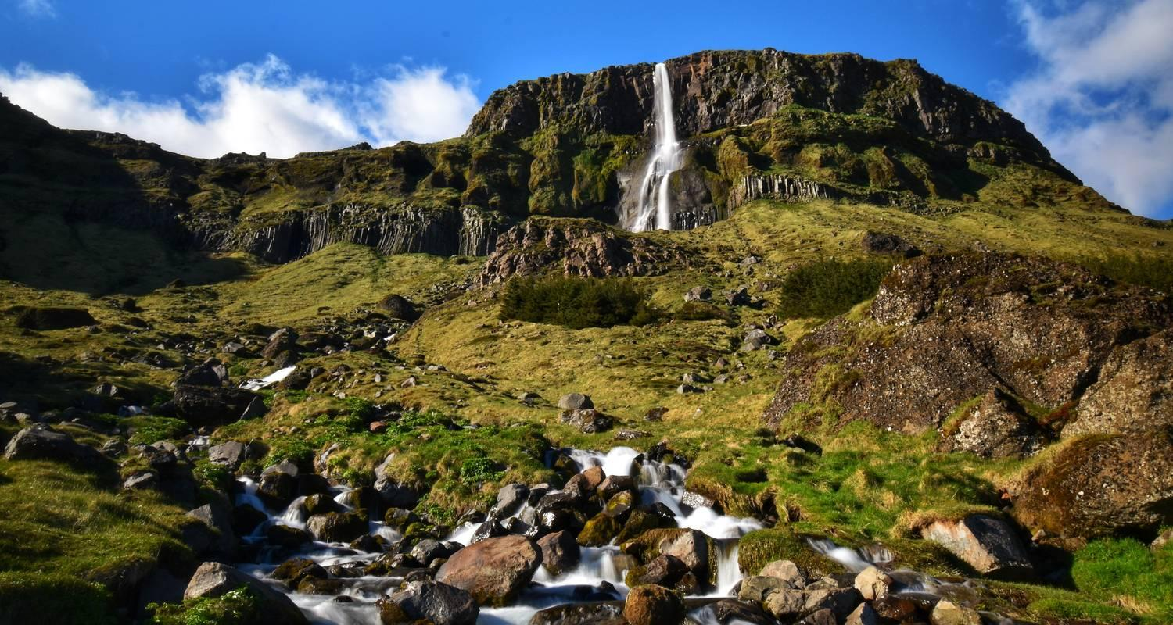

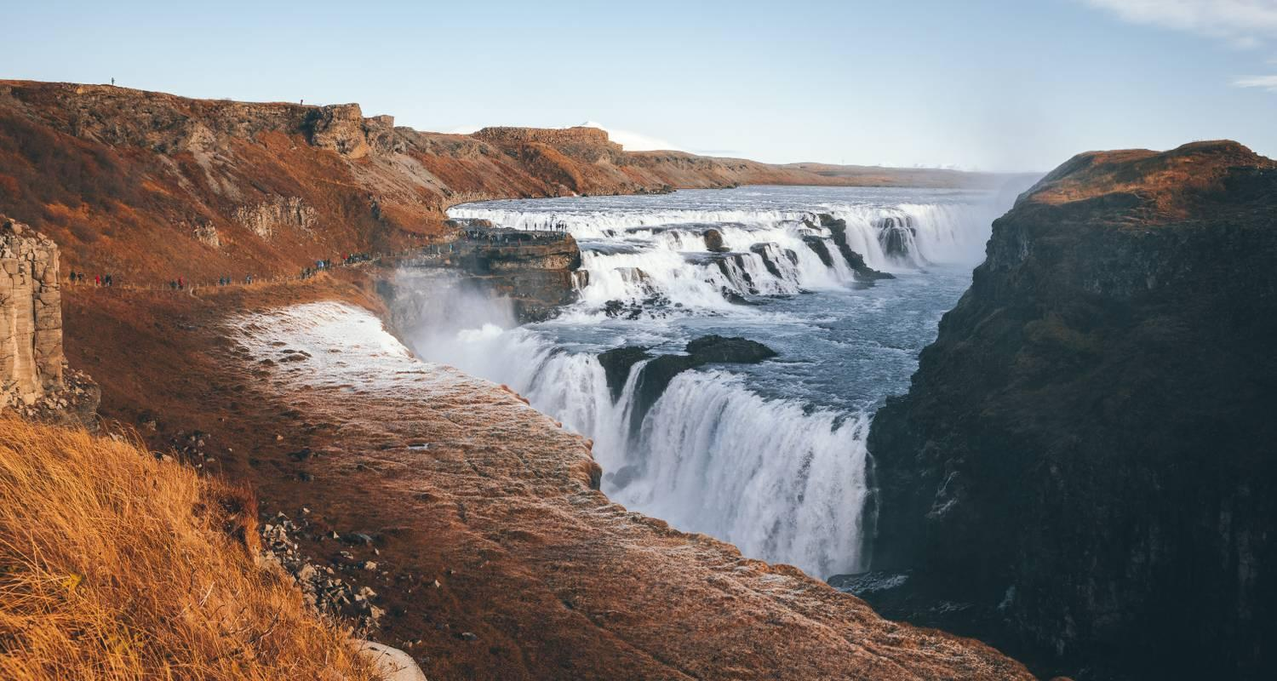

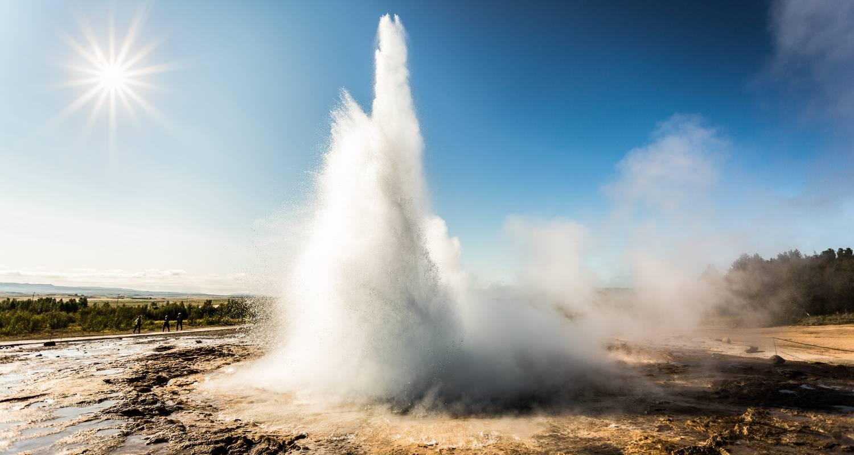

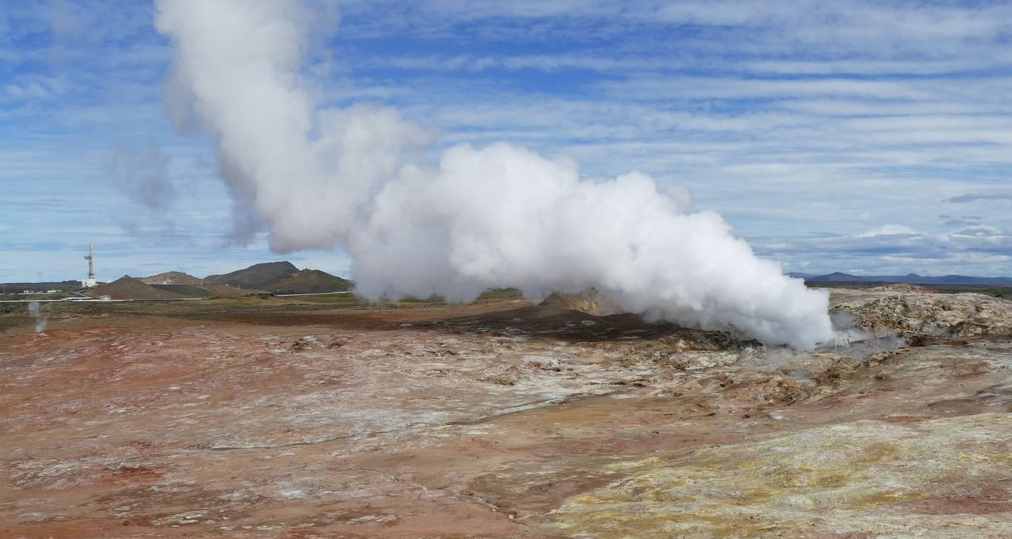

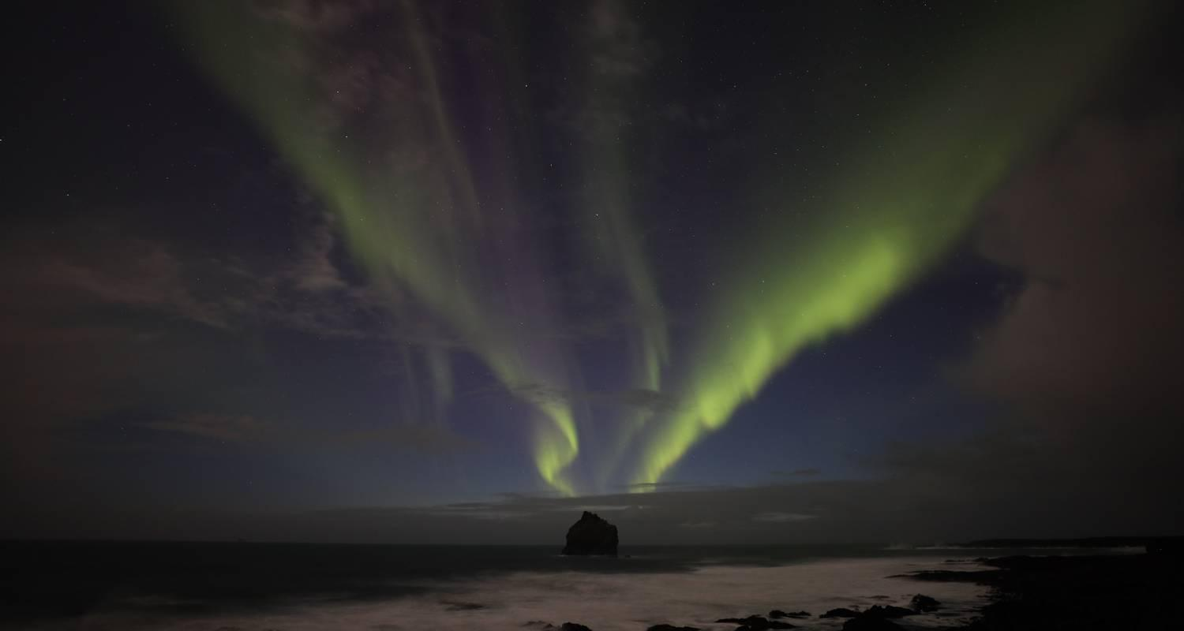

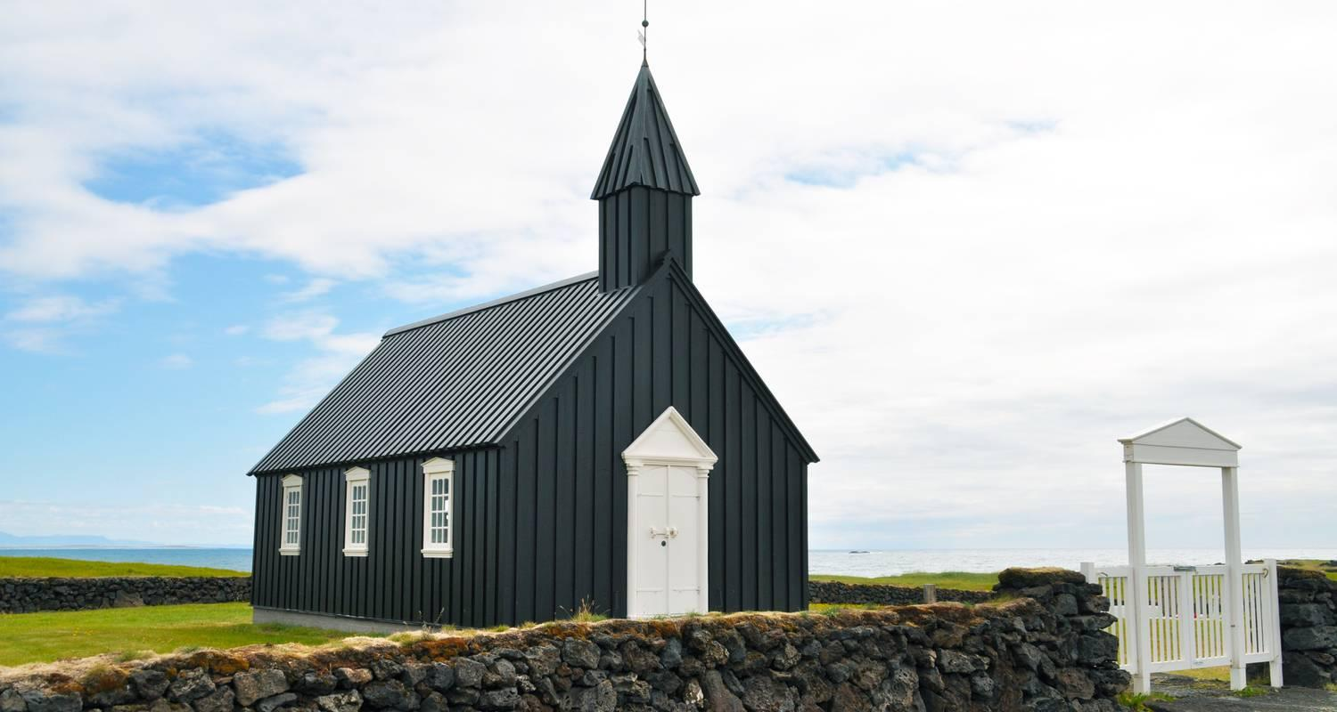

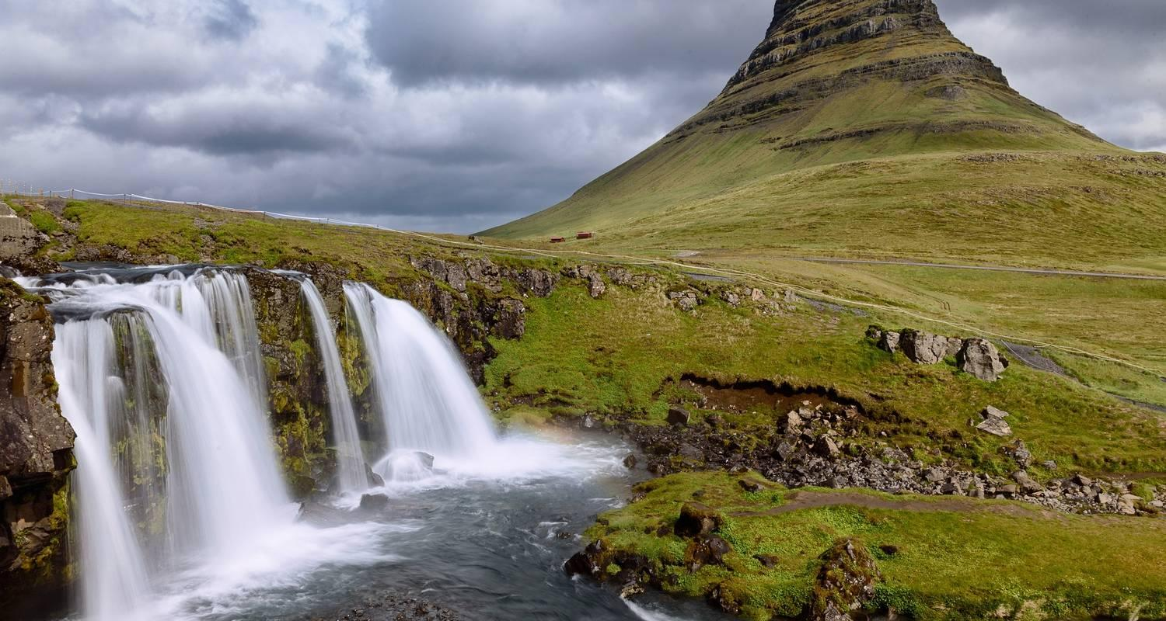

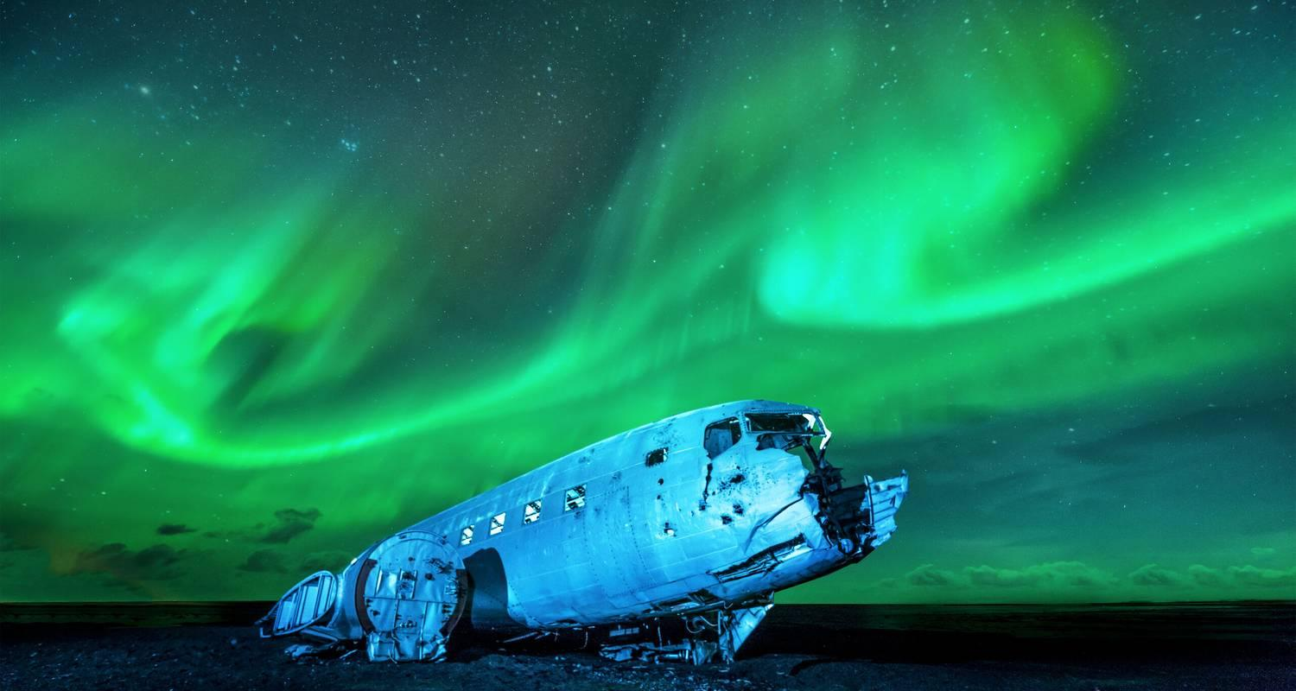

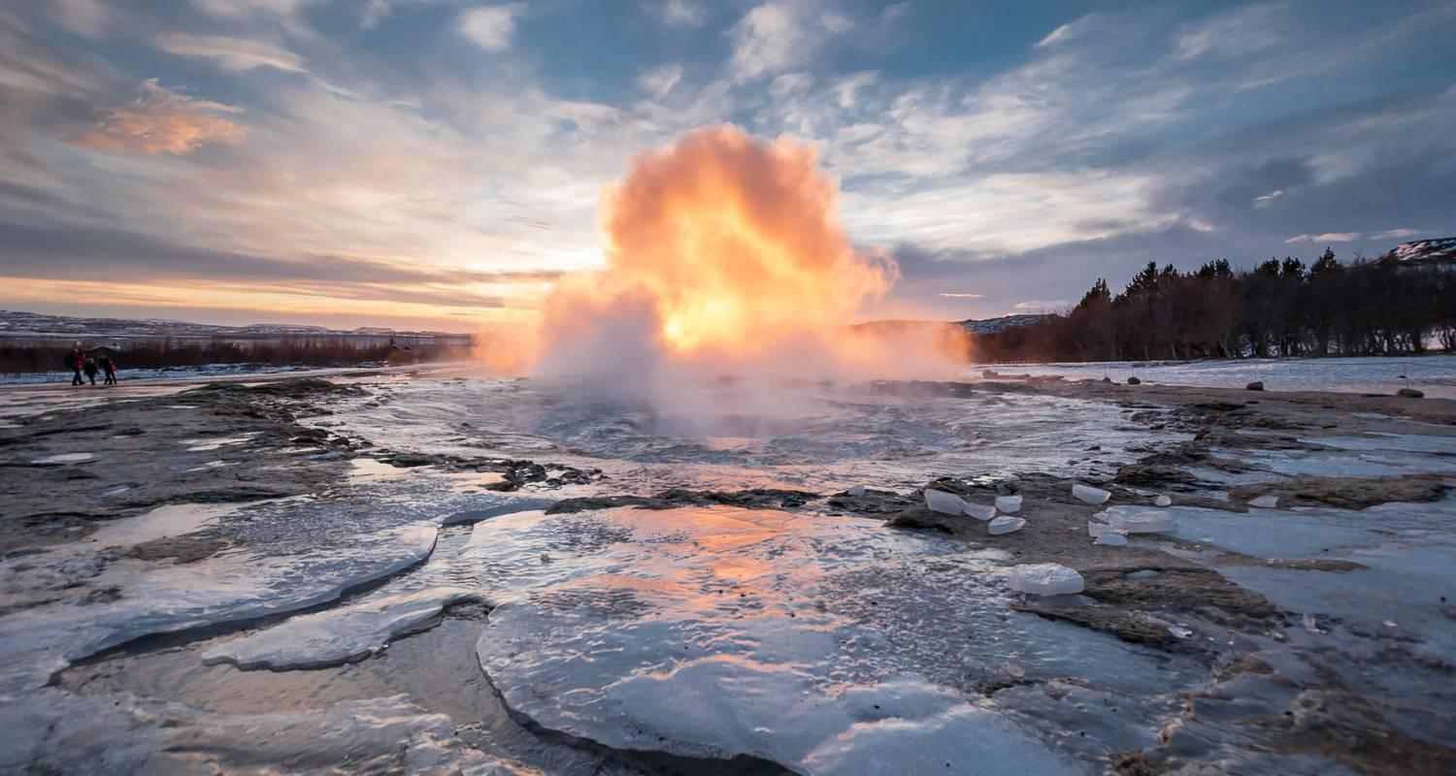

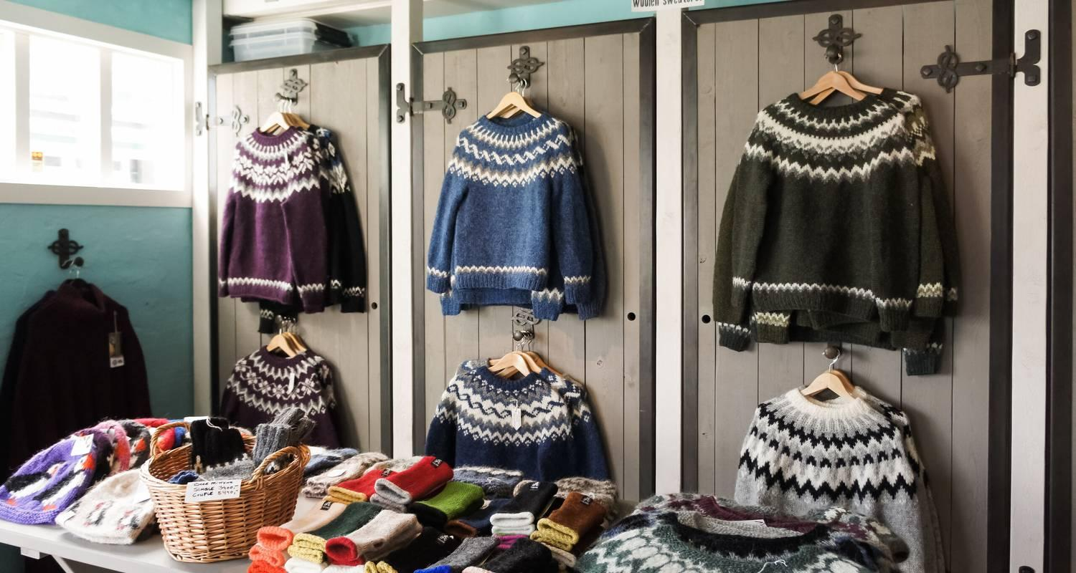

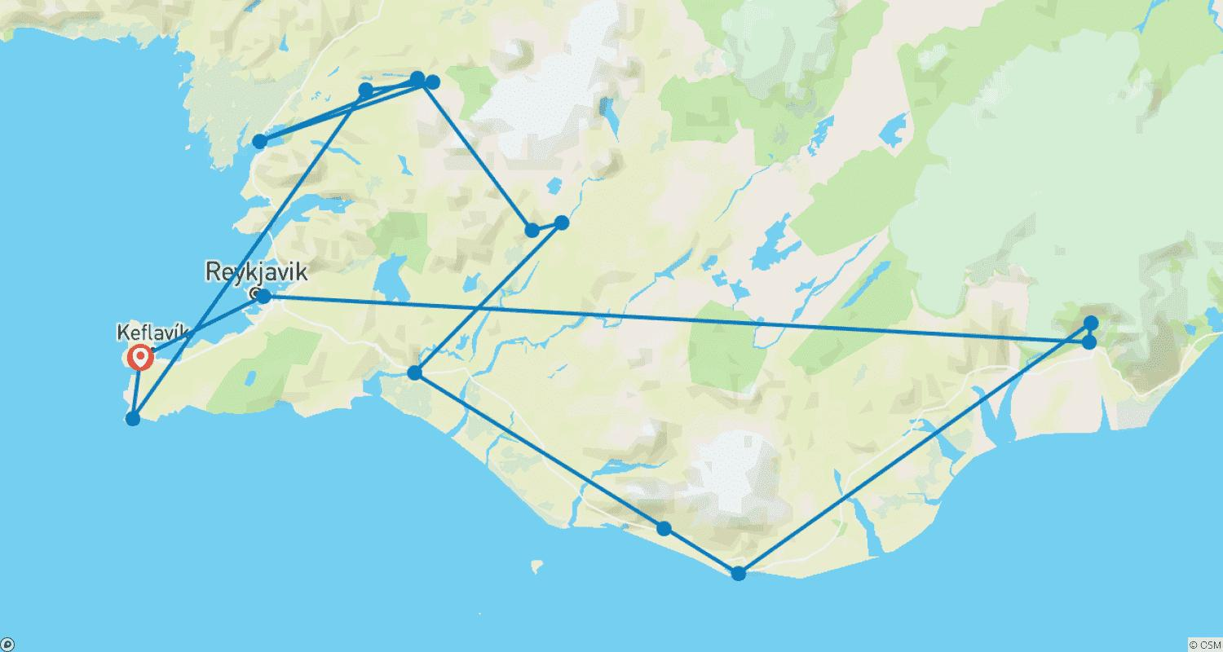

Tour ID: 258380  
Tour Name: Iceland Adventure: Of Volcanic Craters & Wild Fjords

Tour destinations: ['Reykjavik', 'Keflavik', 'Selfoss', 'Gullfoss', 'Skogafoss', 'Vik', 'Hofn', 'Skaftafell', 'Svartifoss', 'Egilsstadir', 'Dettifoss', 'Hverarönd', 'Myvatn', 'Godafoss', 'Akureyri', 'Husavik', 'Laugarbakki', 'Stykkisholmur', 'Hellnar', 'Snæfellsnes', 'Hraunfossar', 'Akranes']

Tour destinations images:

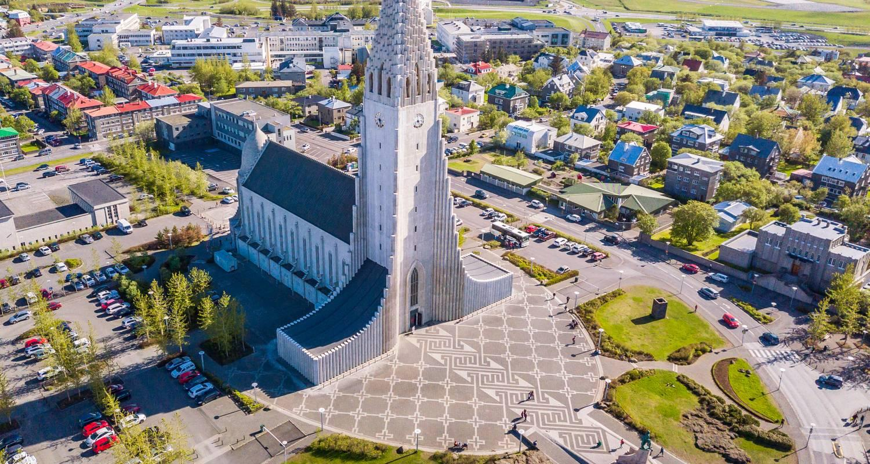

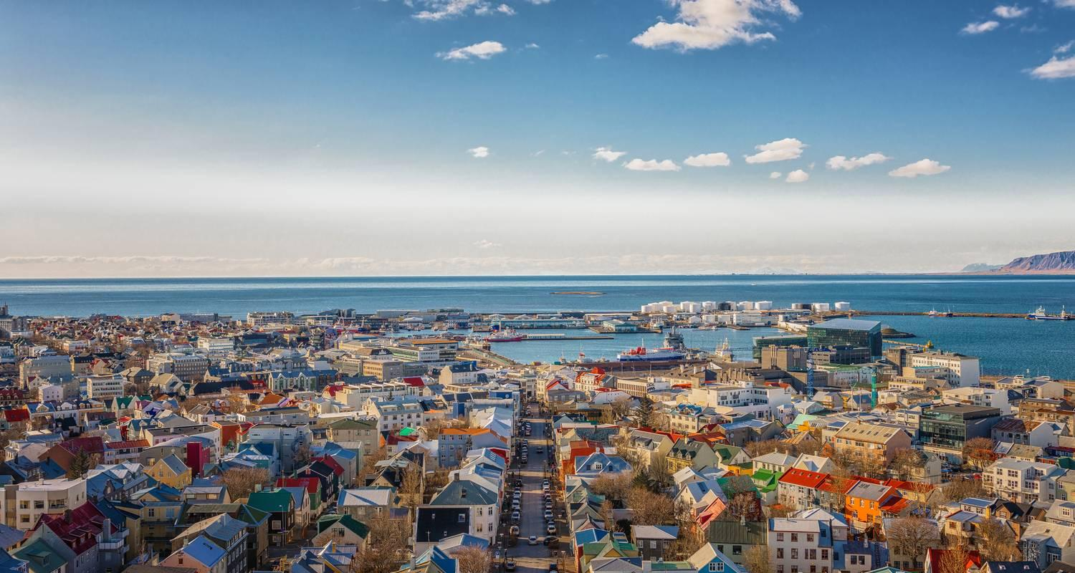

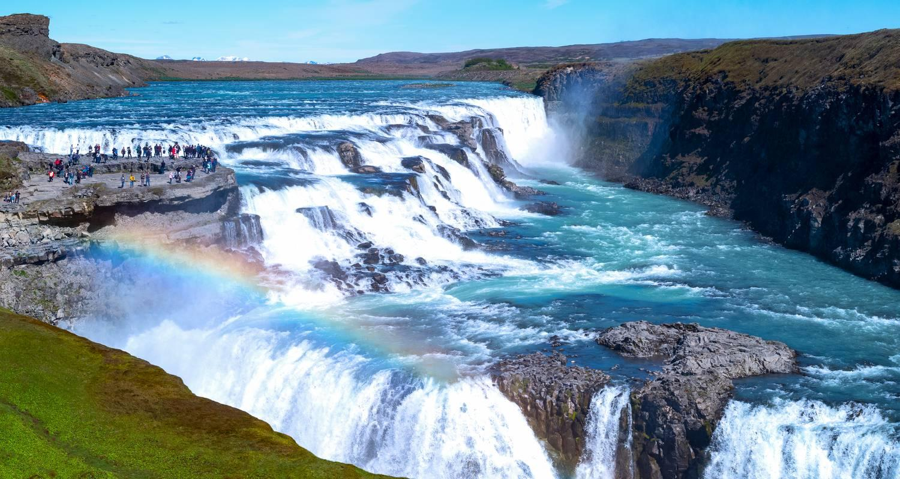

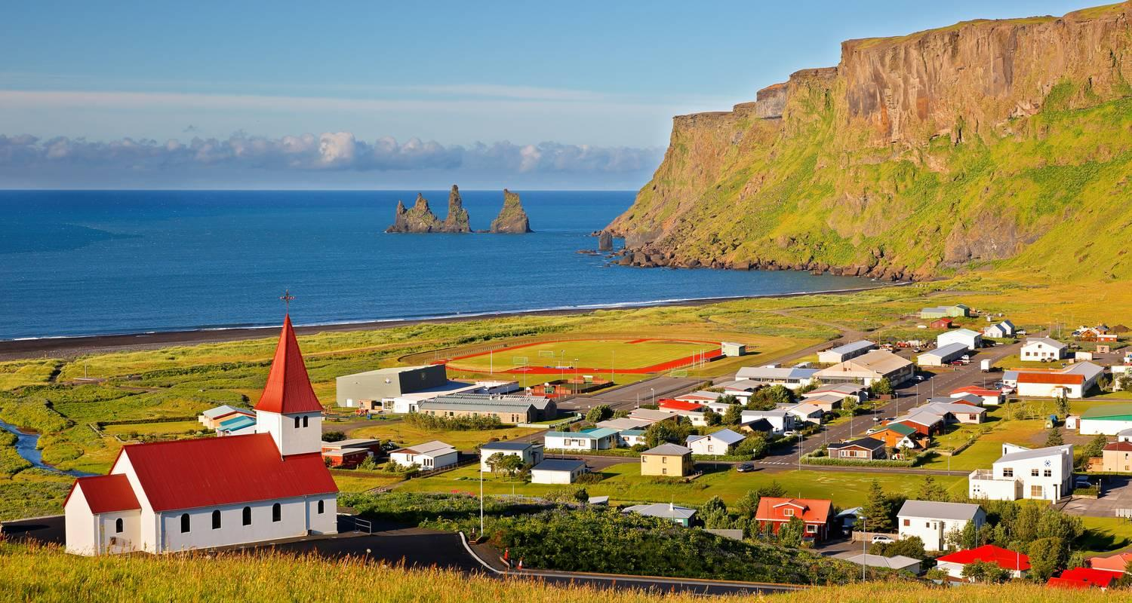

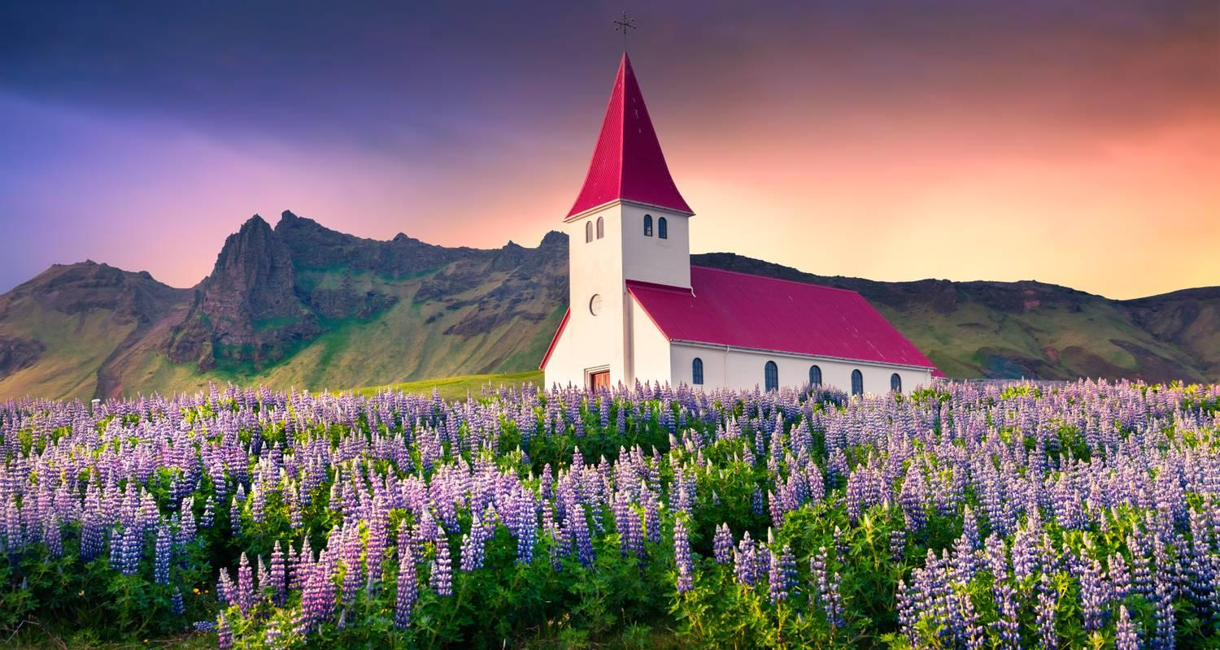

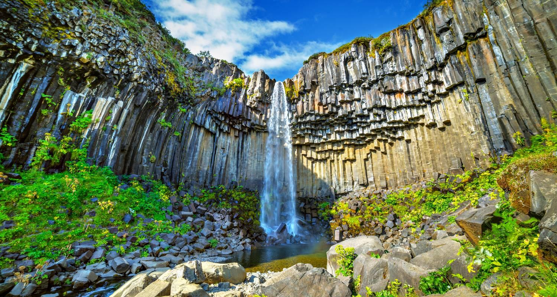

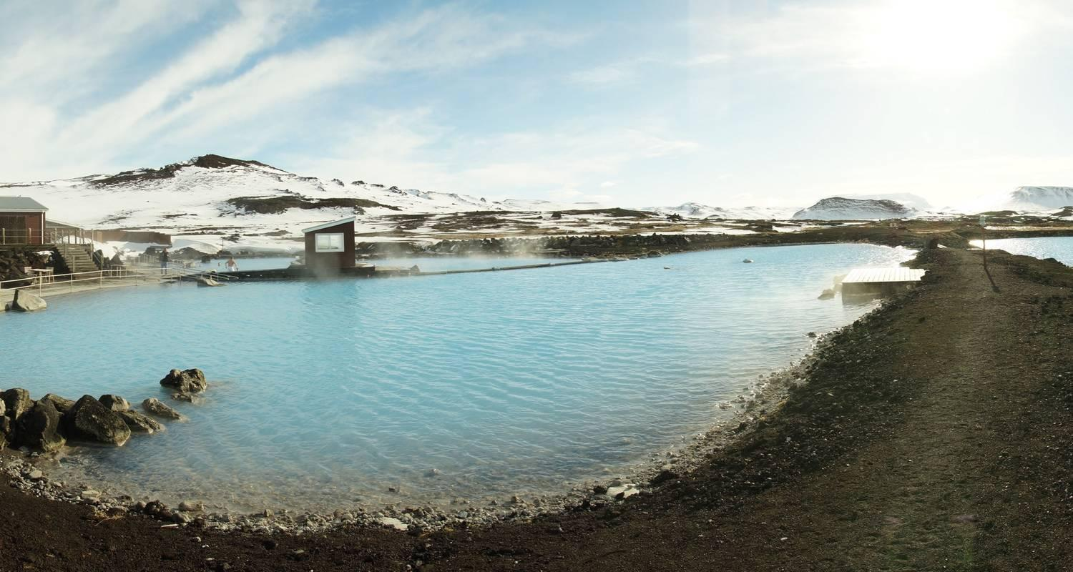

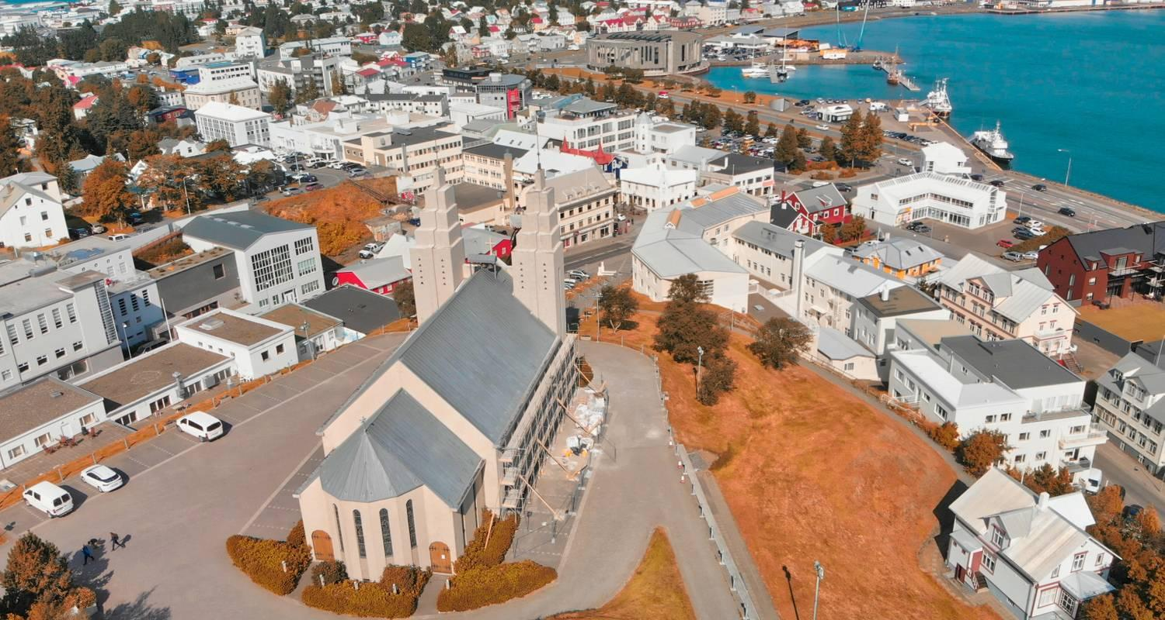

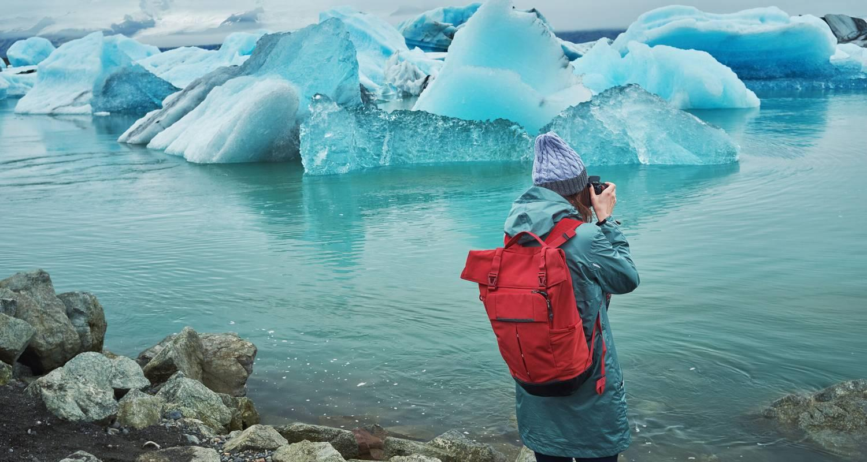

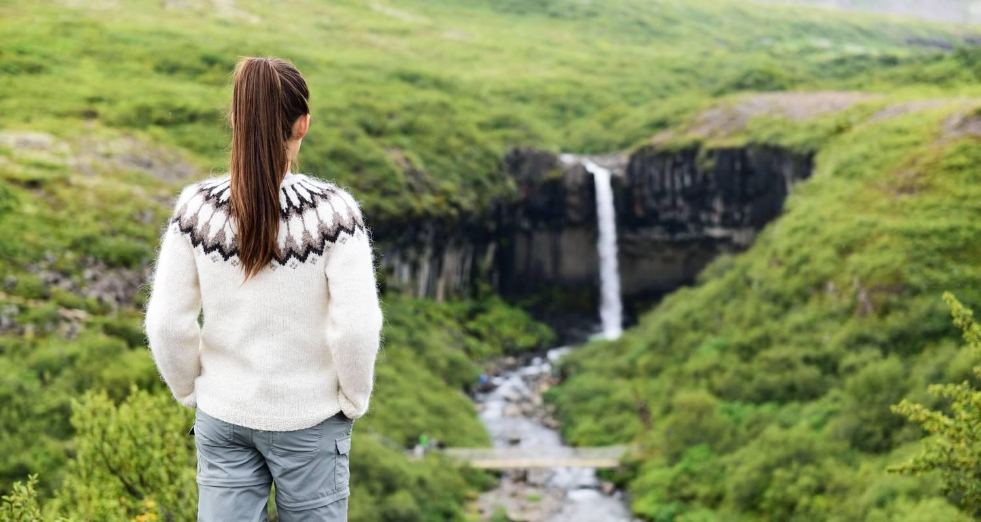

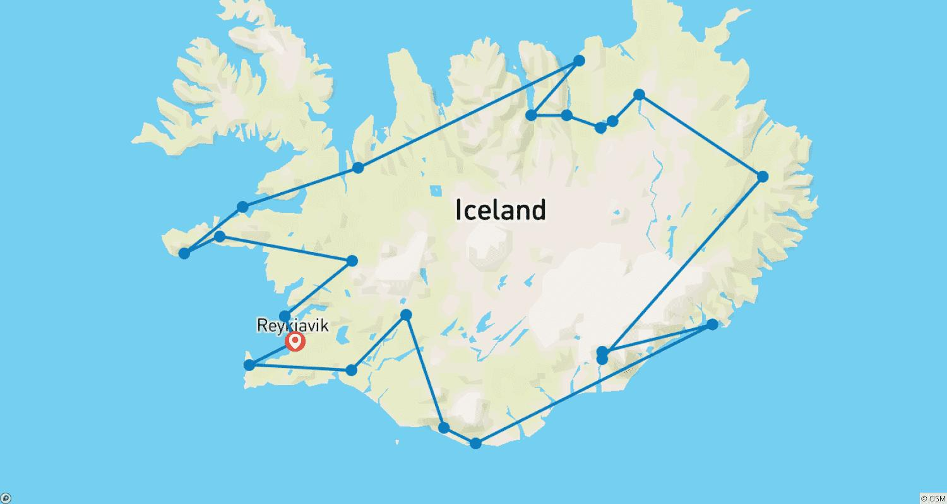

Tour ID: 258392  
Tour Name: Iceland Road Trip: Ice Cold Glaciers & Hot Geysers

Tour destinations: ['Keflavik', 'Reykjavik', 'Selfoss', 'Vik', 'Hofn', 'Egilsstadir', 'Akureyri', 'Husavik', 'Reykholt']

Tour destinations images:

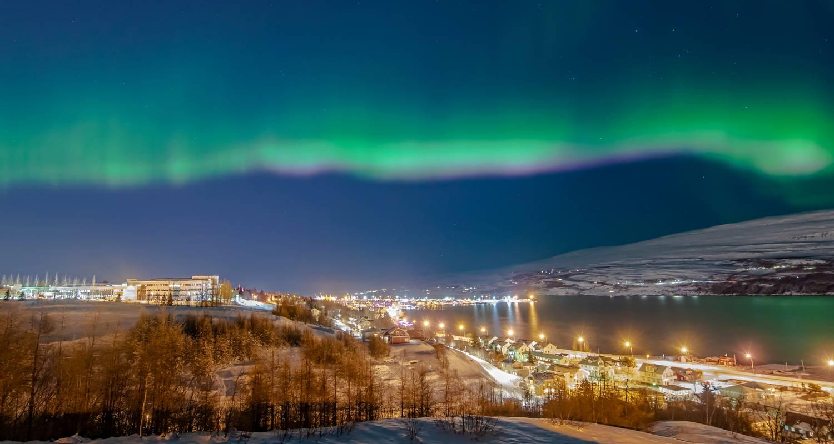





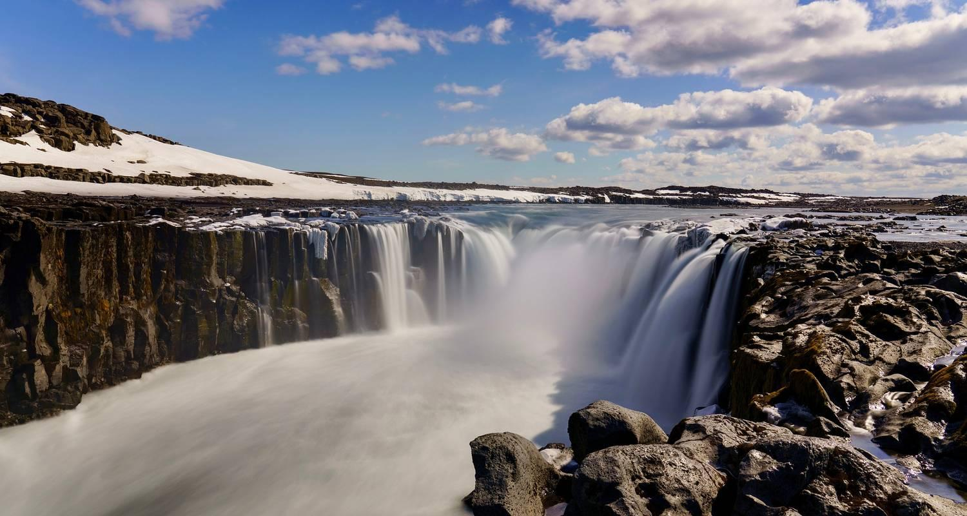

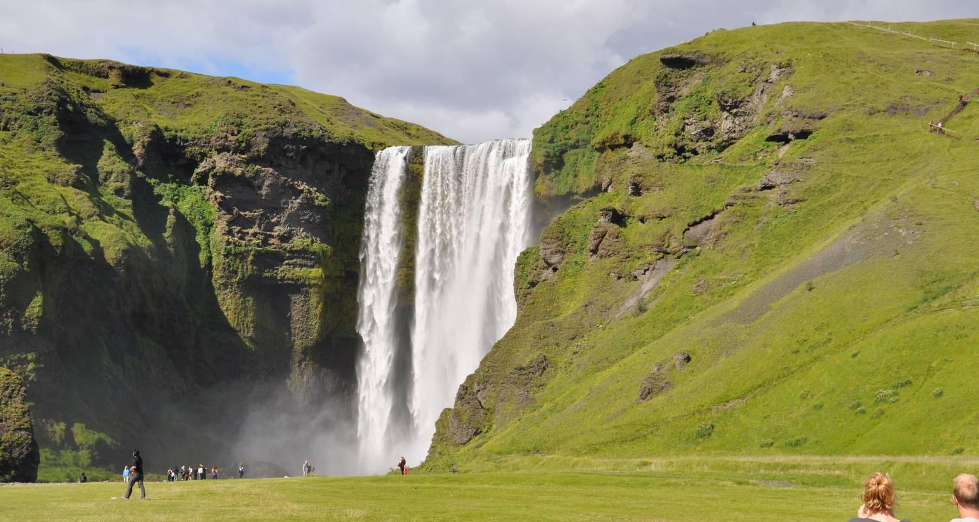

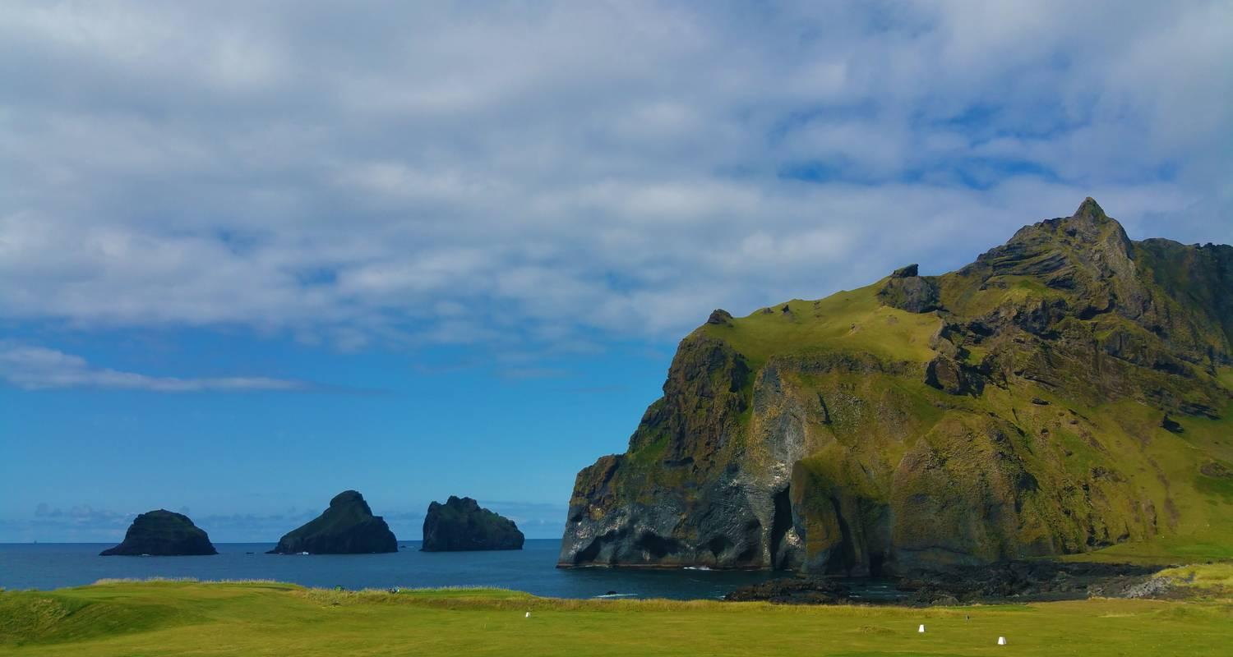

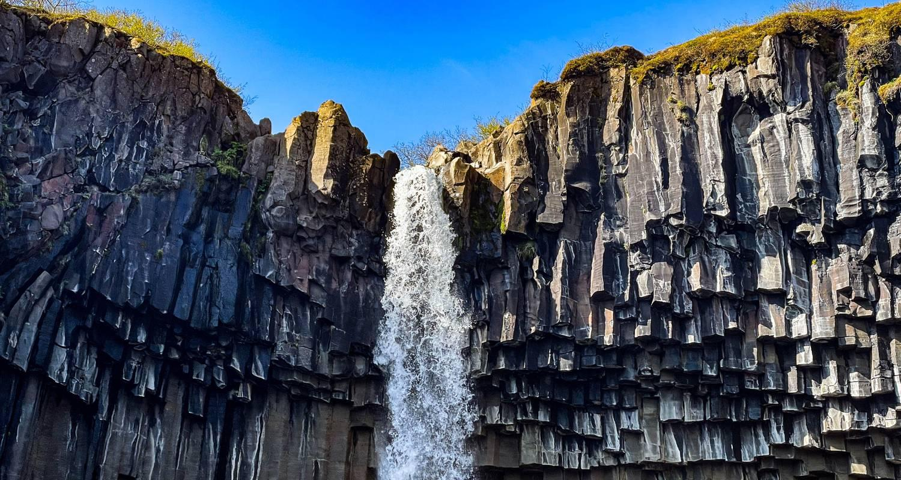

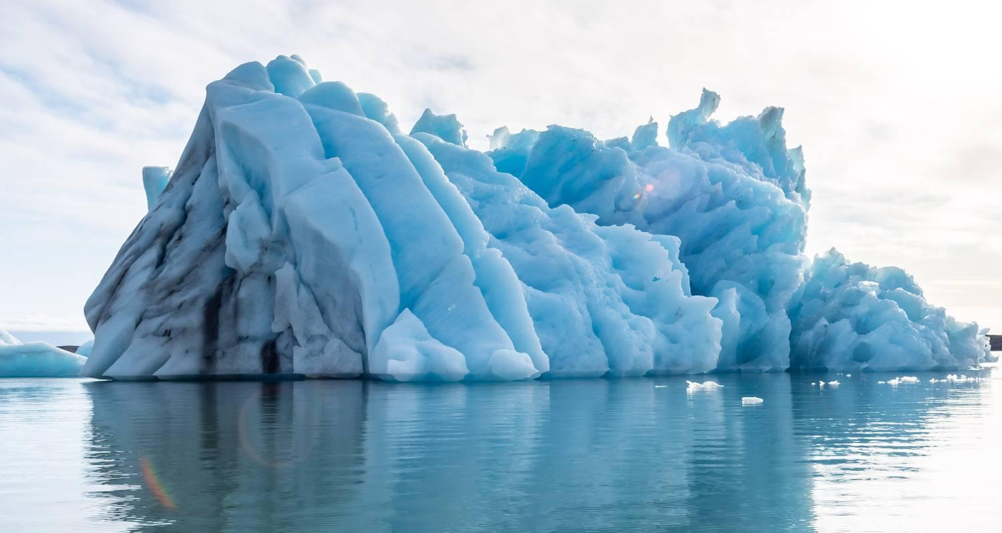

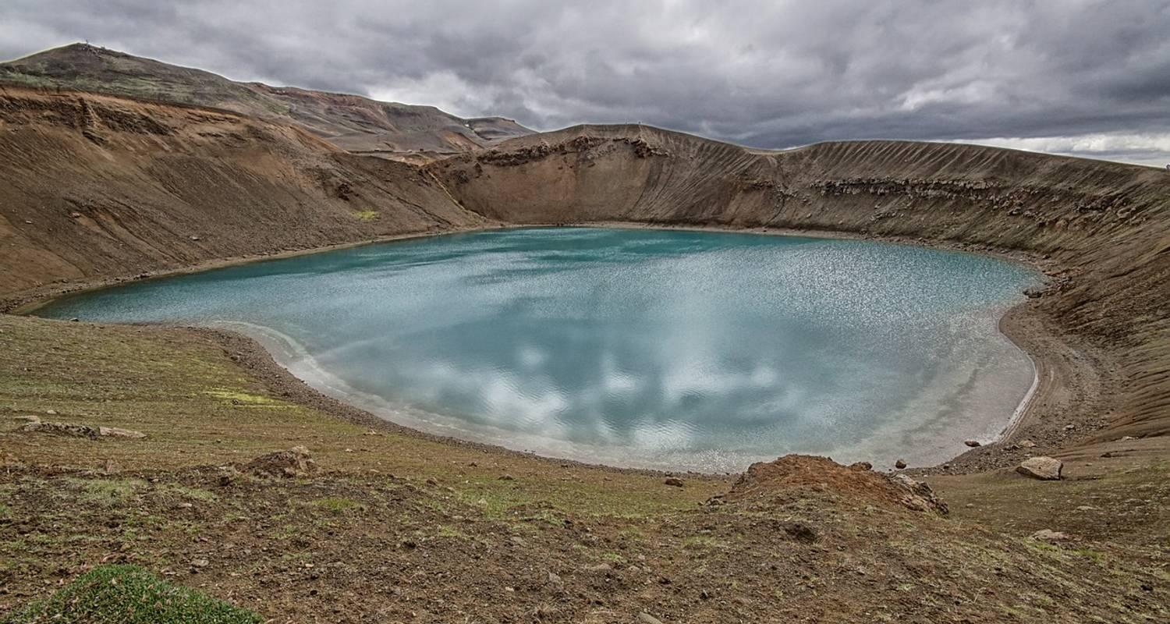

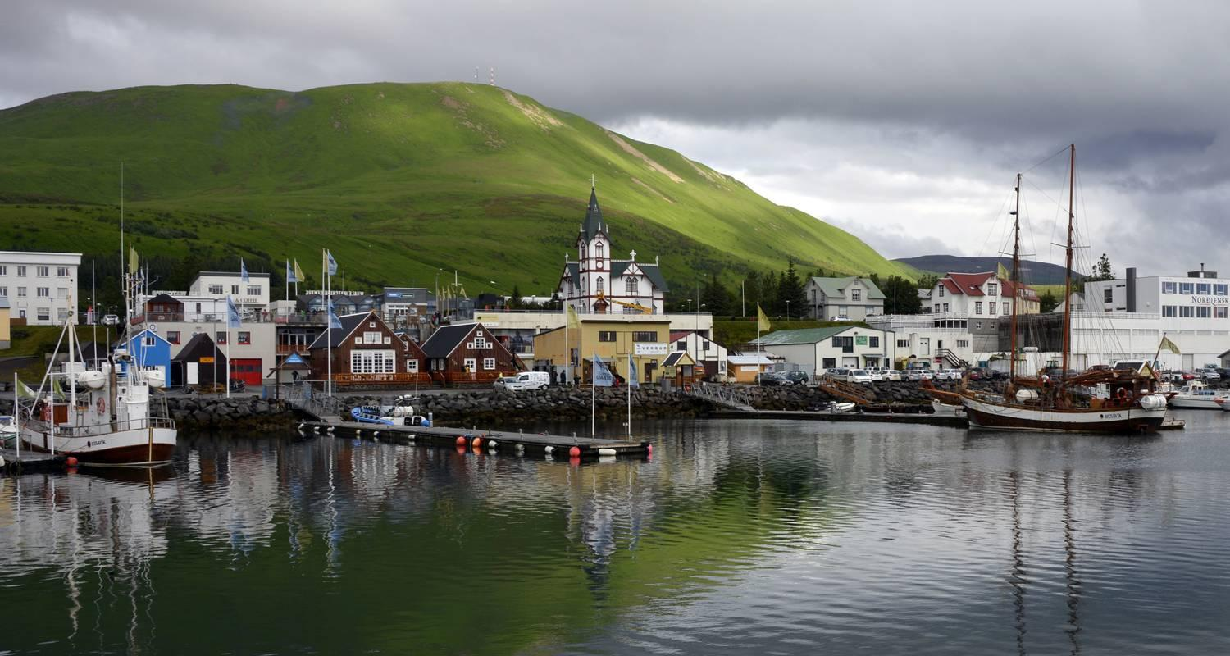

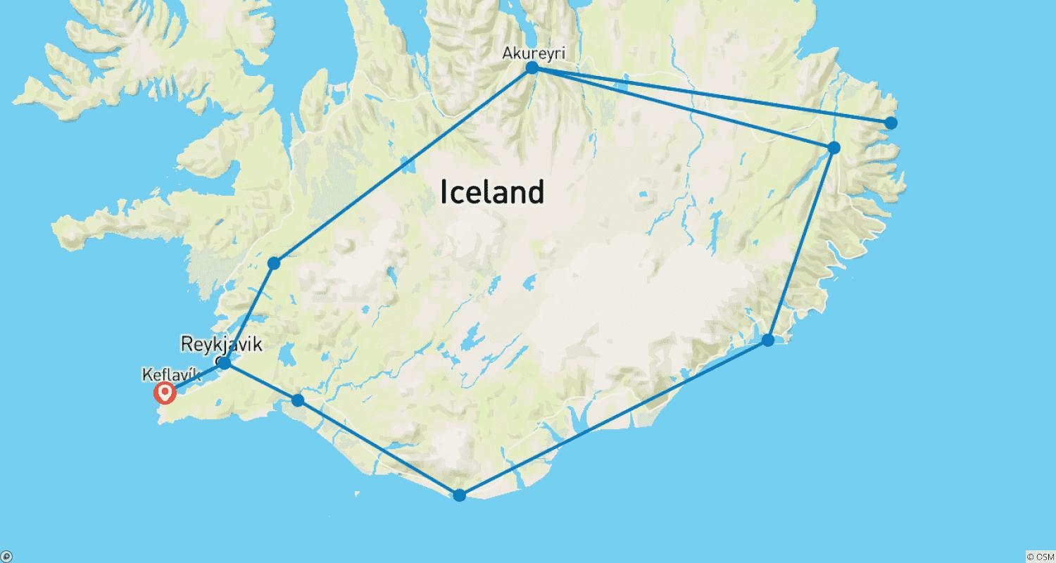

Tour ID: 258410  
Tour Name: Winter Adventure Iceland: Northern Lights & eternal glaciers

Tour destinations: ['Keflavik', 'Gunnuhver', 'Reykholt', 'Thingvellir National Park', 'Húsafell', 'Borgarnes', 'Gullfoss', 'Selfoss', 'Skogafoss', 'Reynisfjara', 'Skaftafell', 'Reykjavik']

Tour destinations images:

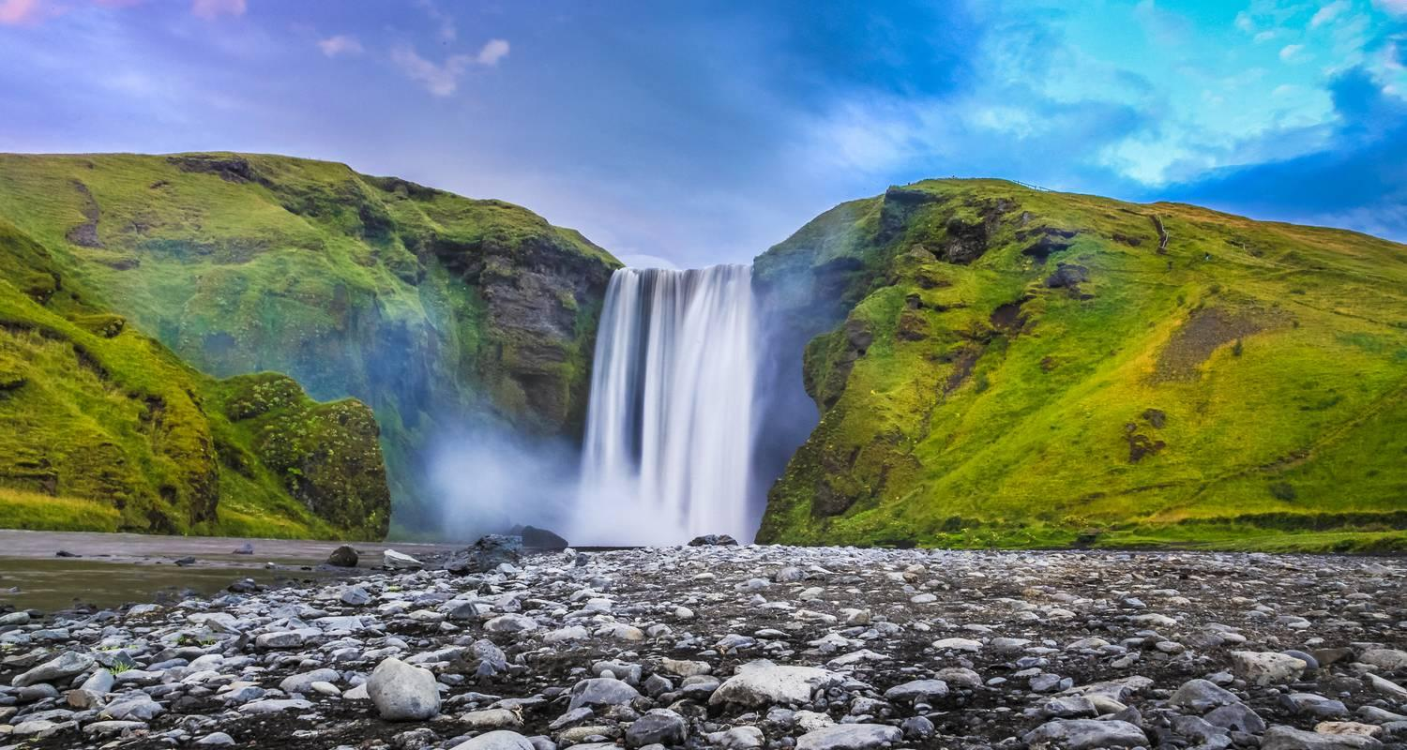

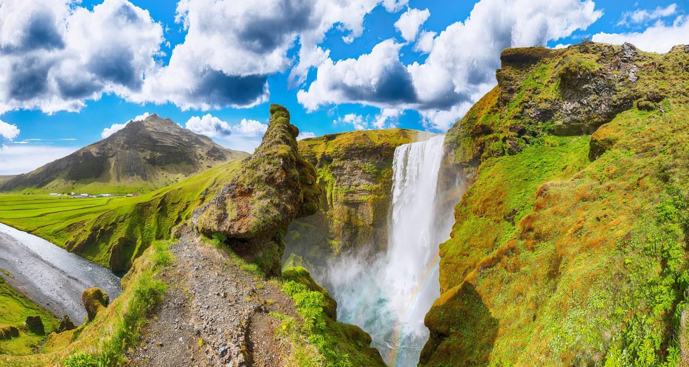

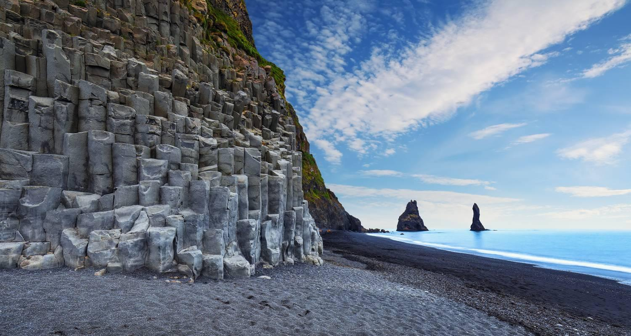

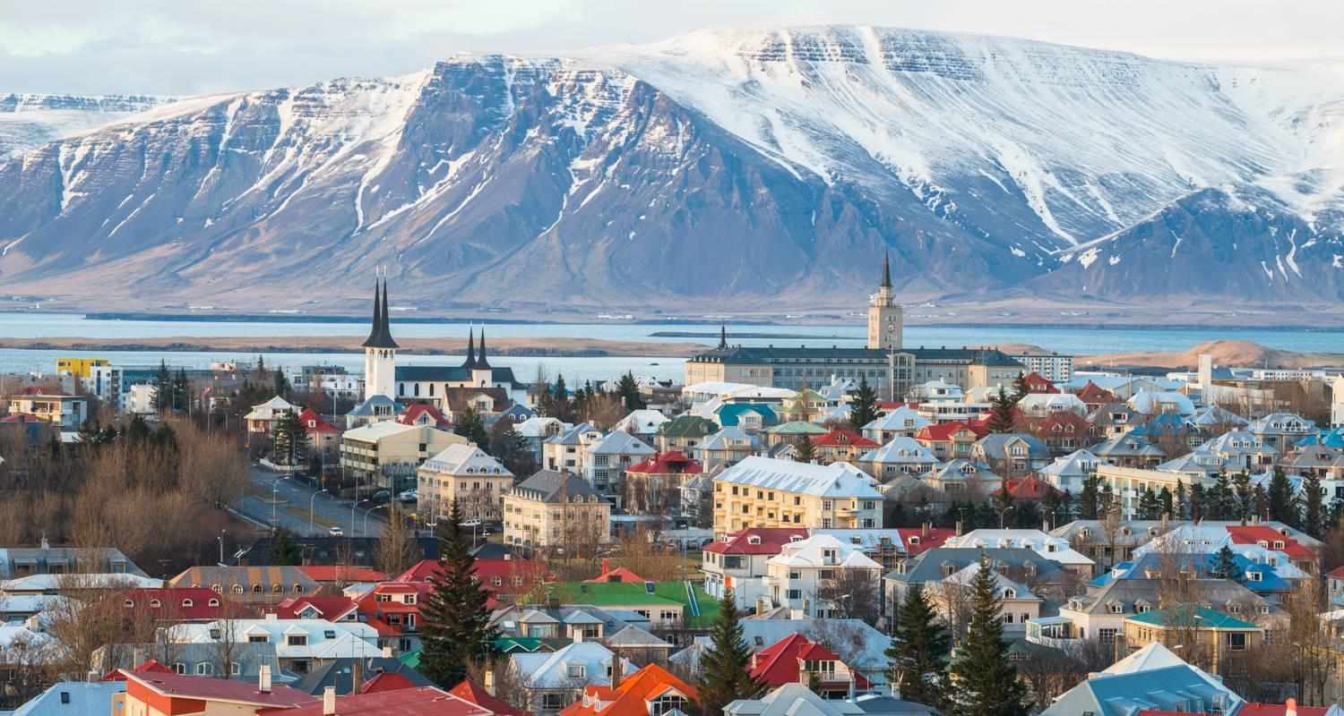



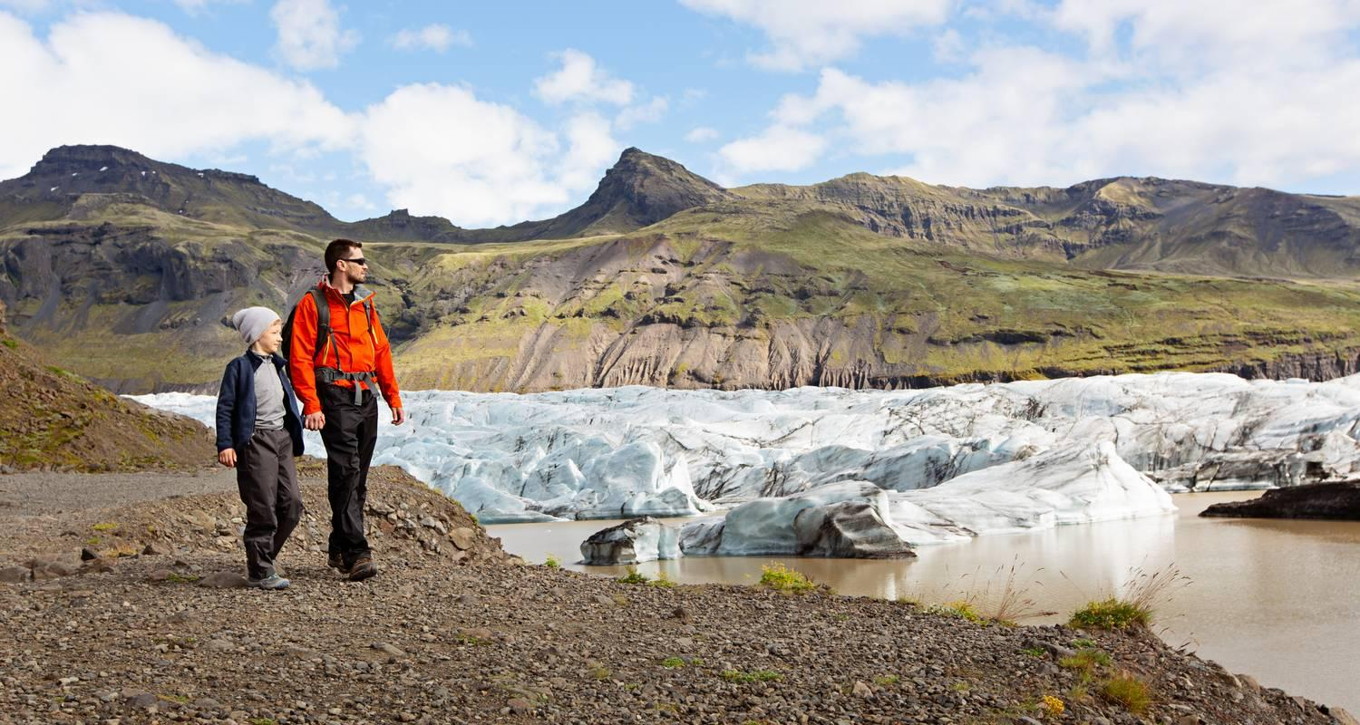

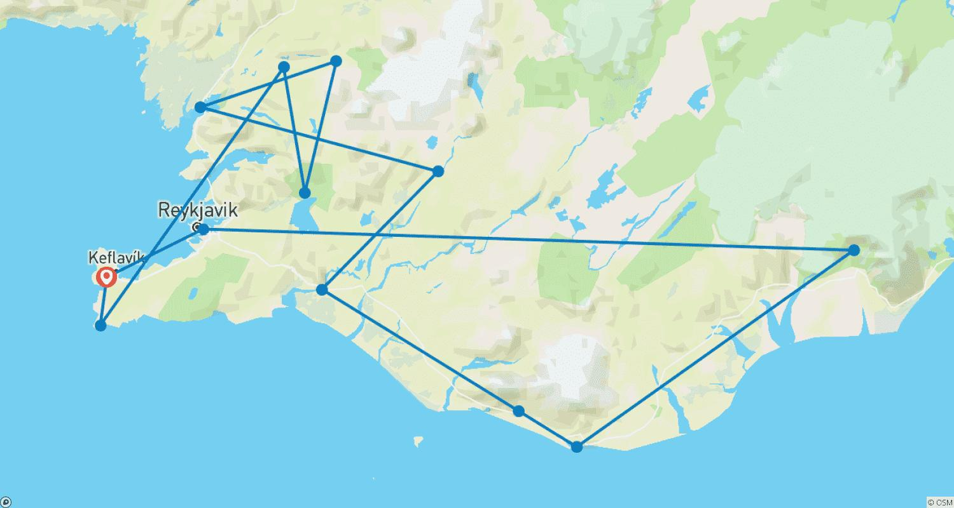

Tour ID: 258431  
Tour Name: Iceland: South Coast Road Trip Adventure

Tour destinations: ['Keflavik', 'Reykholt', 'Djupalonssandur', 'Kirkjufell Mountain', 'Skogafoss', 'Reynisfjara', 'Vik', 'Svartifoss', 'Skaftafell', 'Gullfoss', 'Thingvellir National Park', 'Reykjavik']

Tour destinations images:

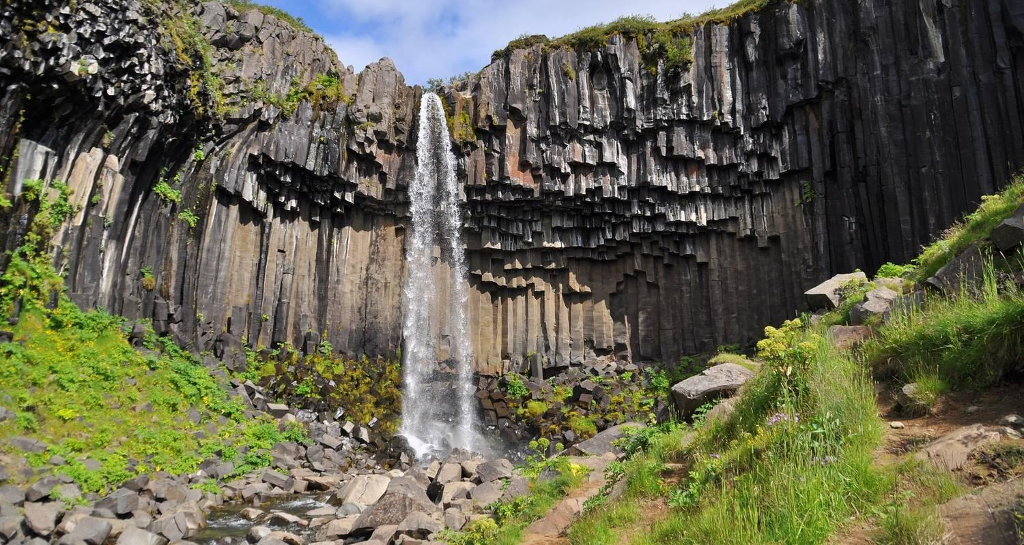

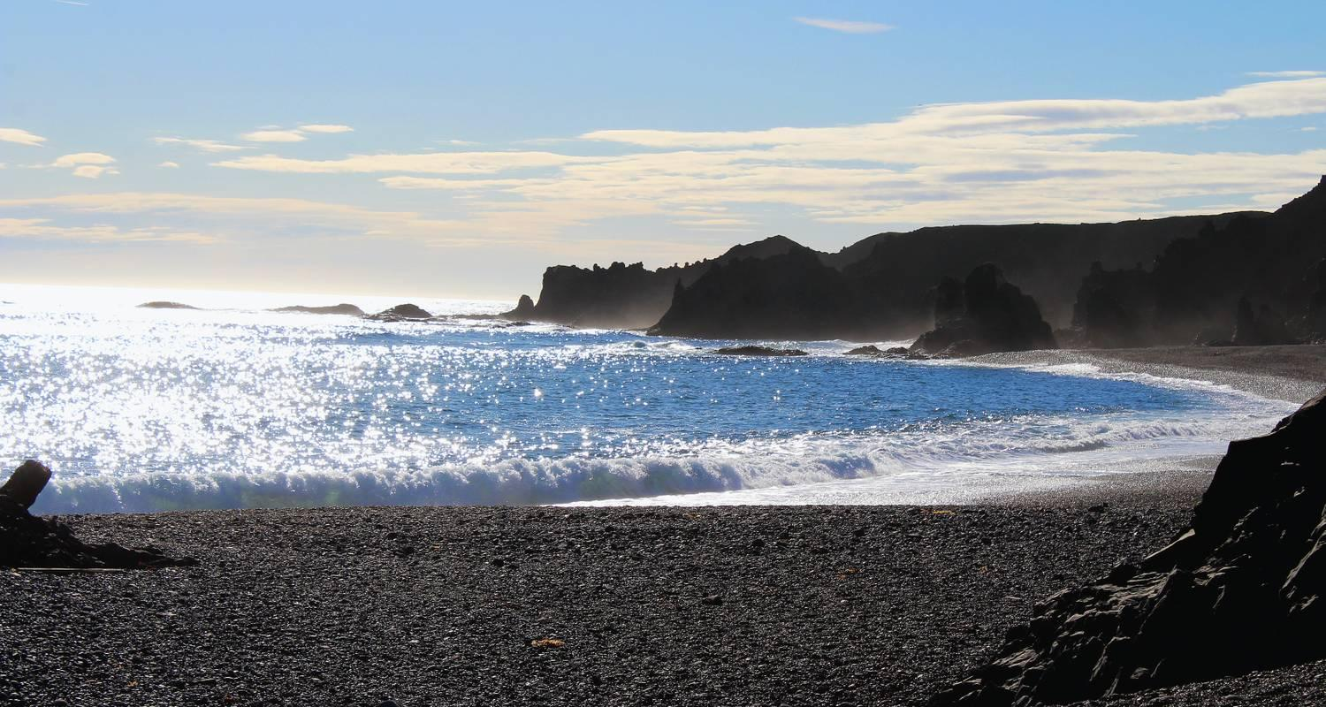

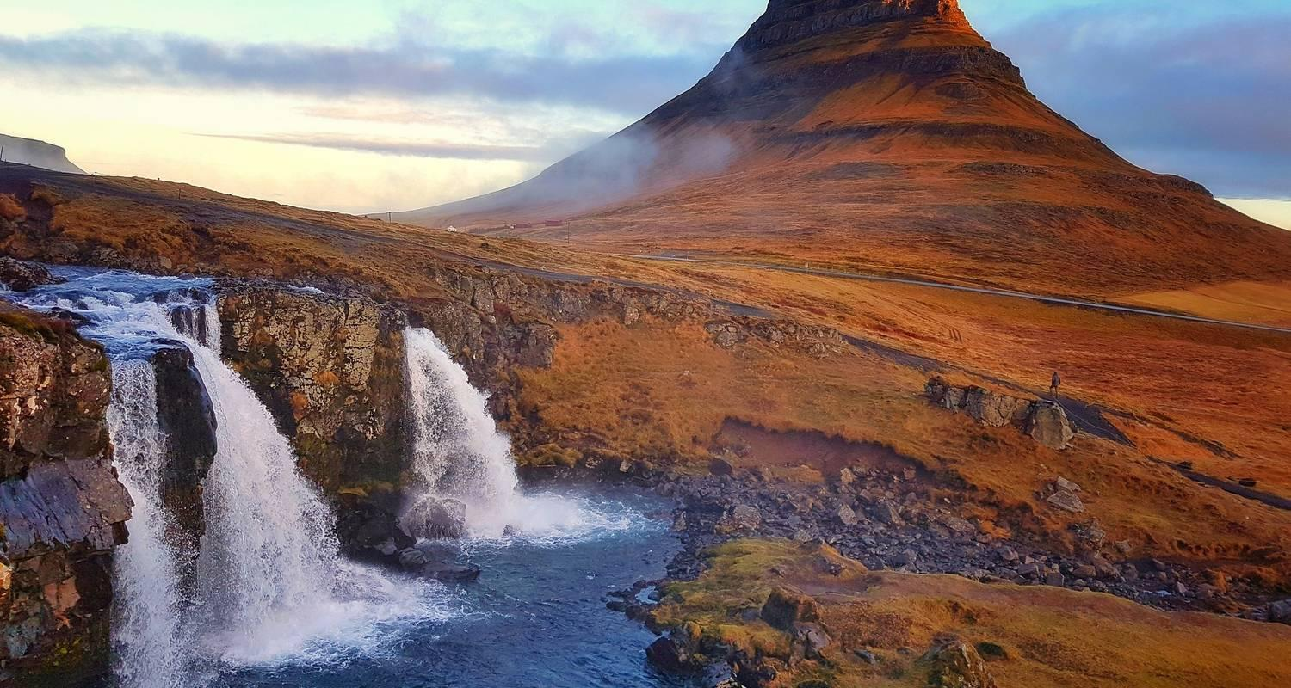

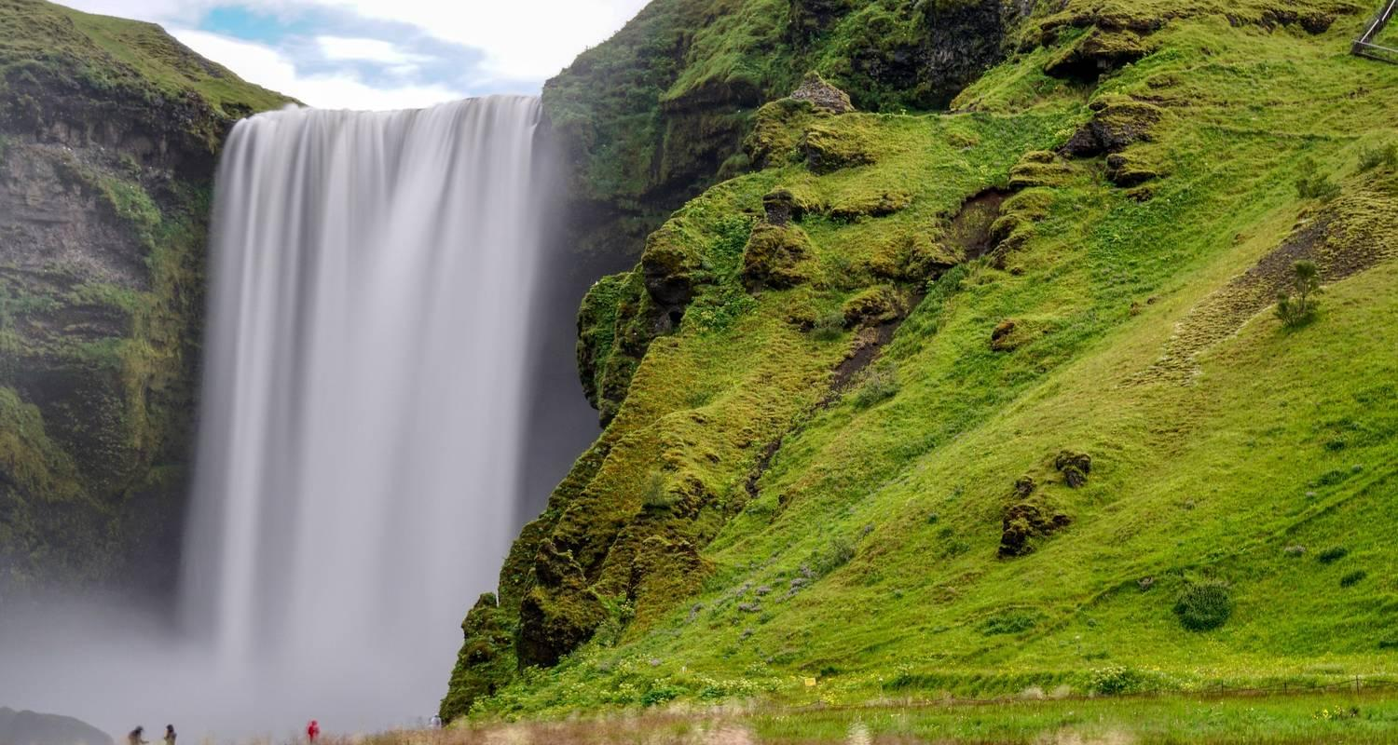

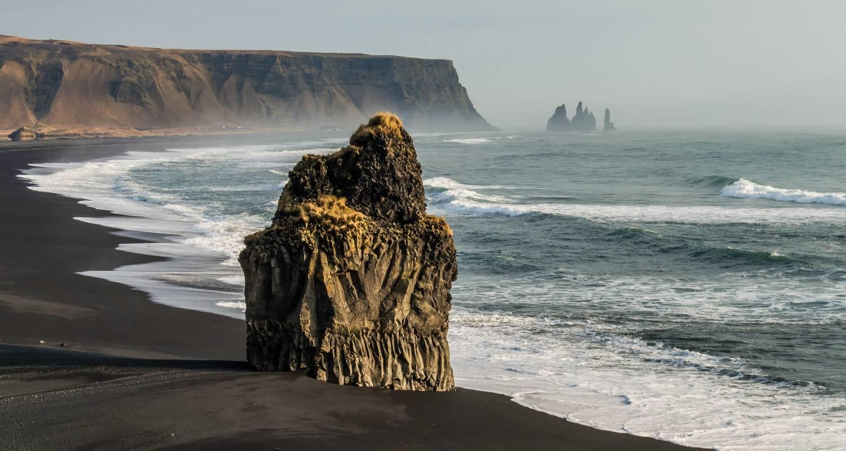

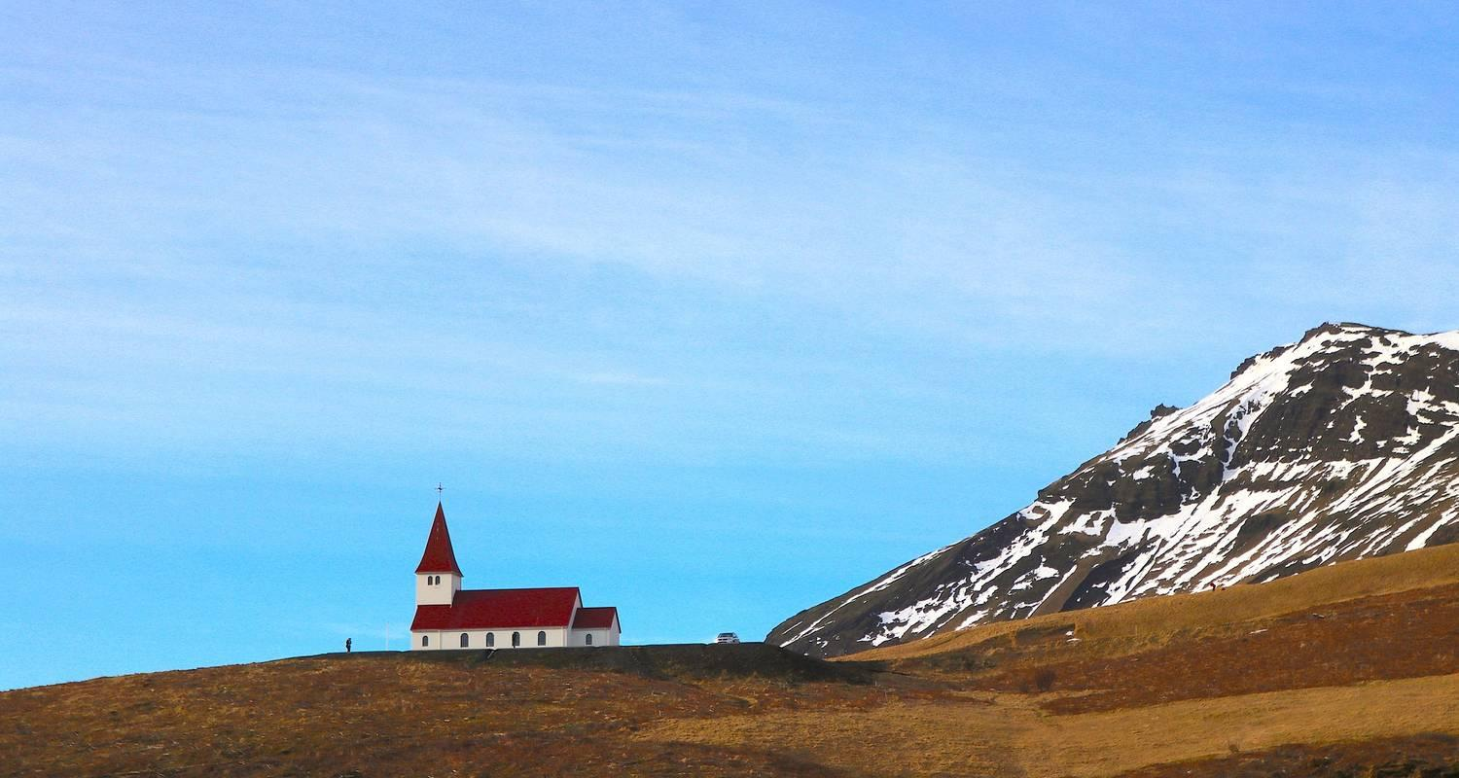

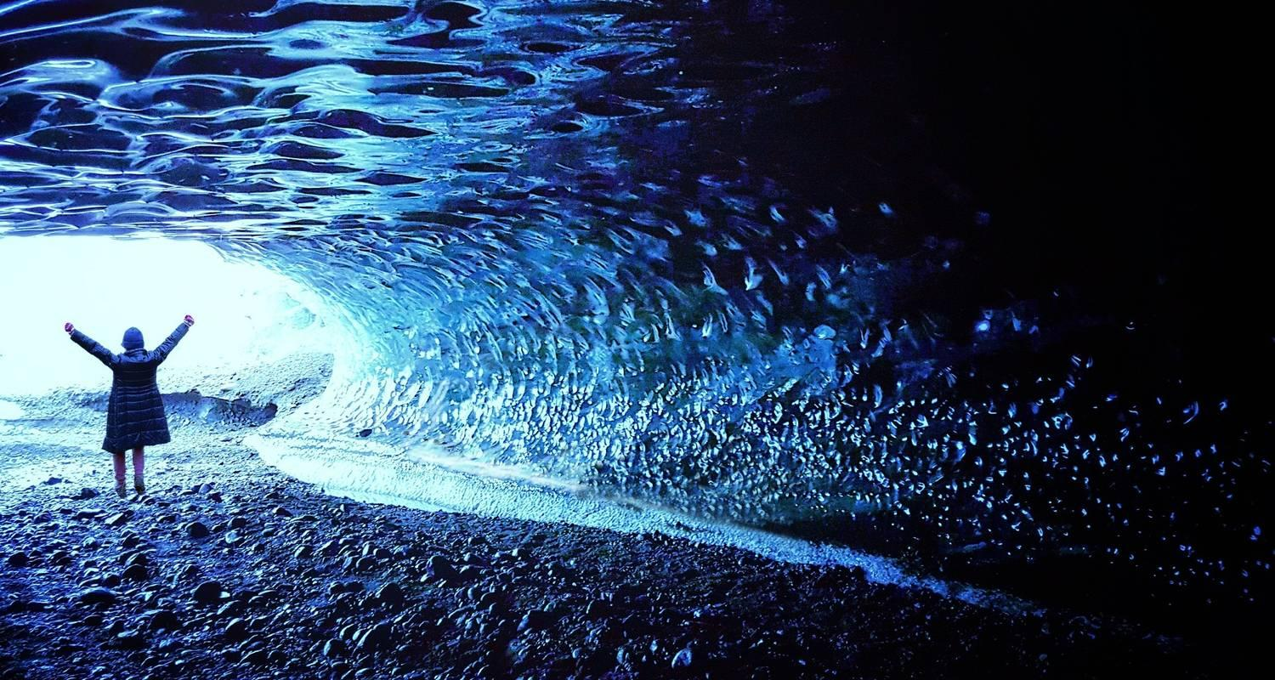

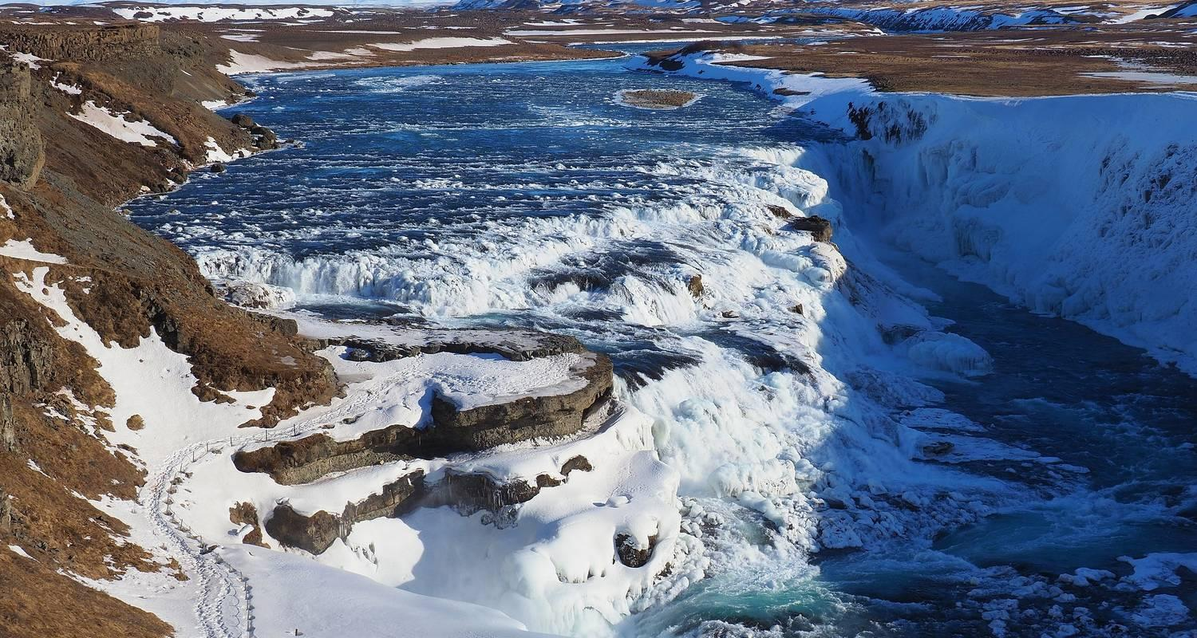

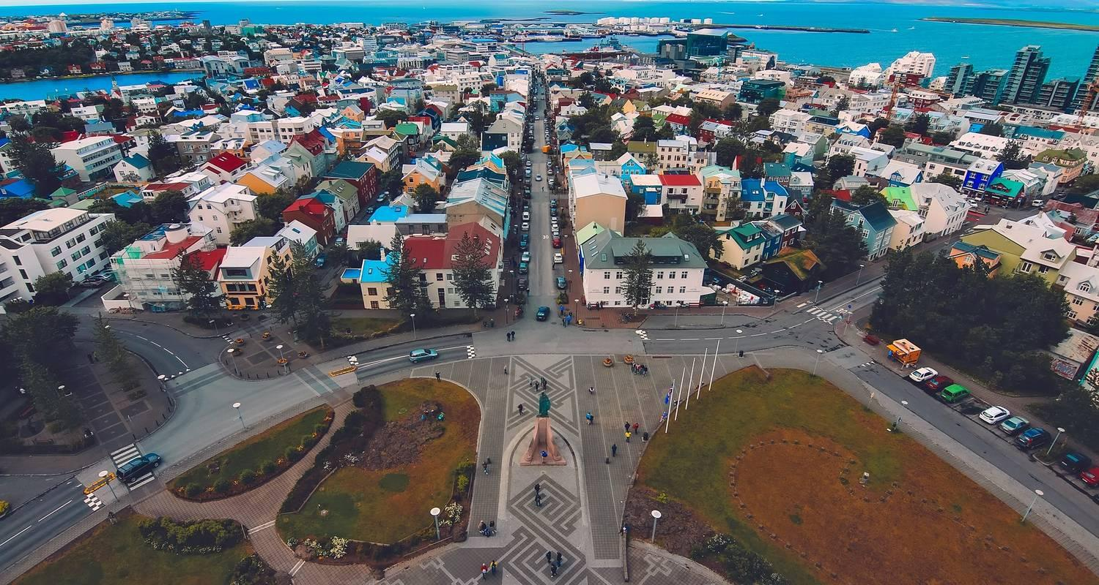

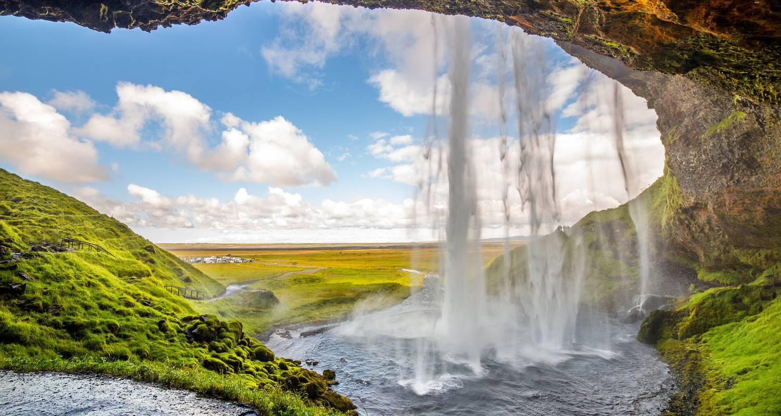

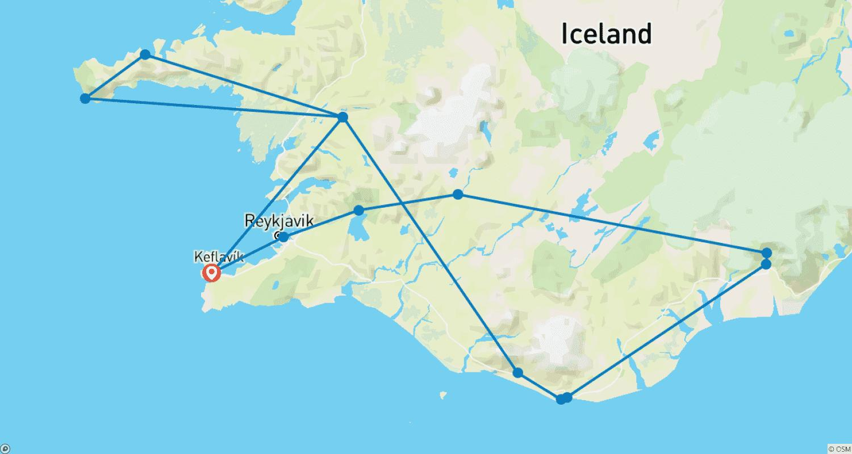

Tour ID: 258454  
Tour Name: Iceland's South Coast: Road Trip Adventure to Sky Lagoon

Tour destinations: ['Keflavik', 'Selfoss', 'Skogafoss', 'Reynisfjara', 'Vik', 'Gullfoss', 'Reykholt', 'Húsafell', 'Reykjavik']

Tour destinations images:

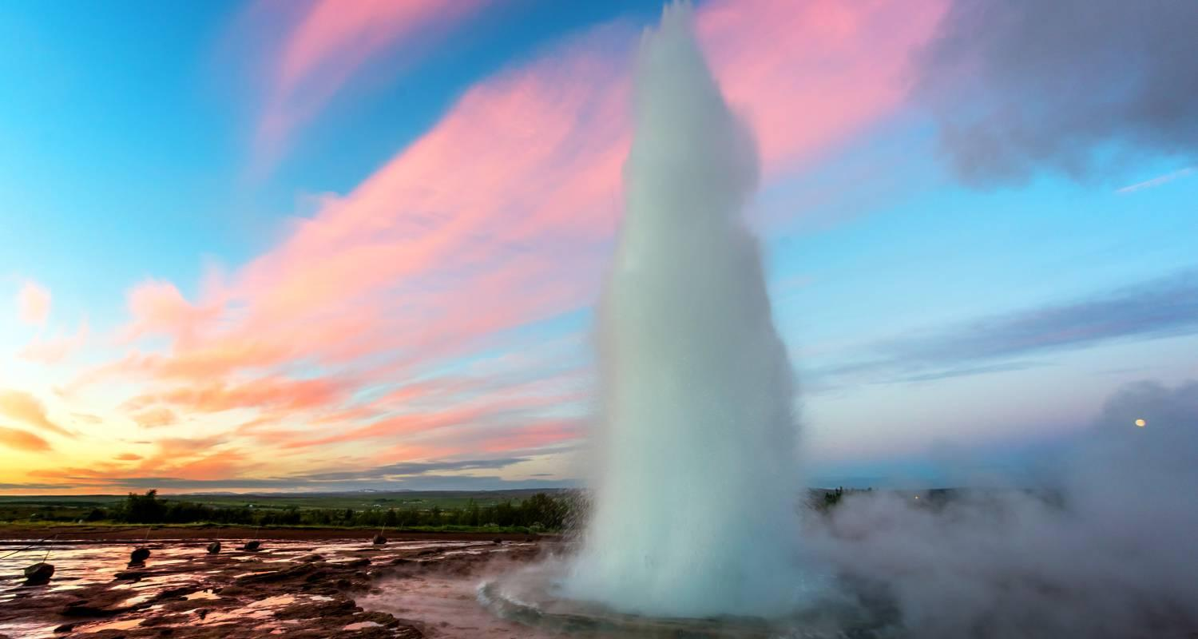

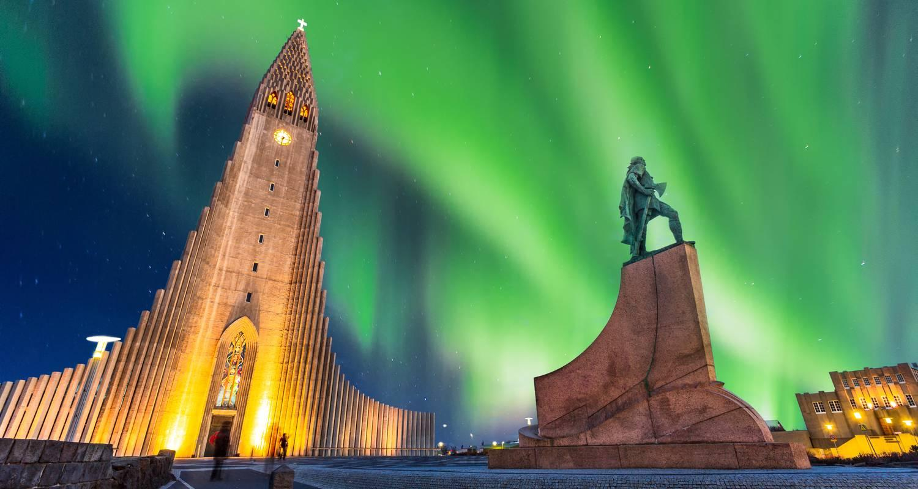

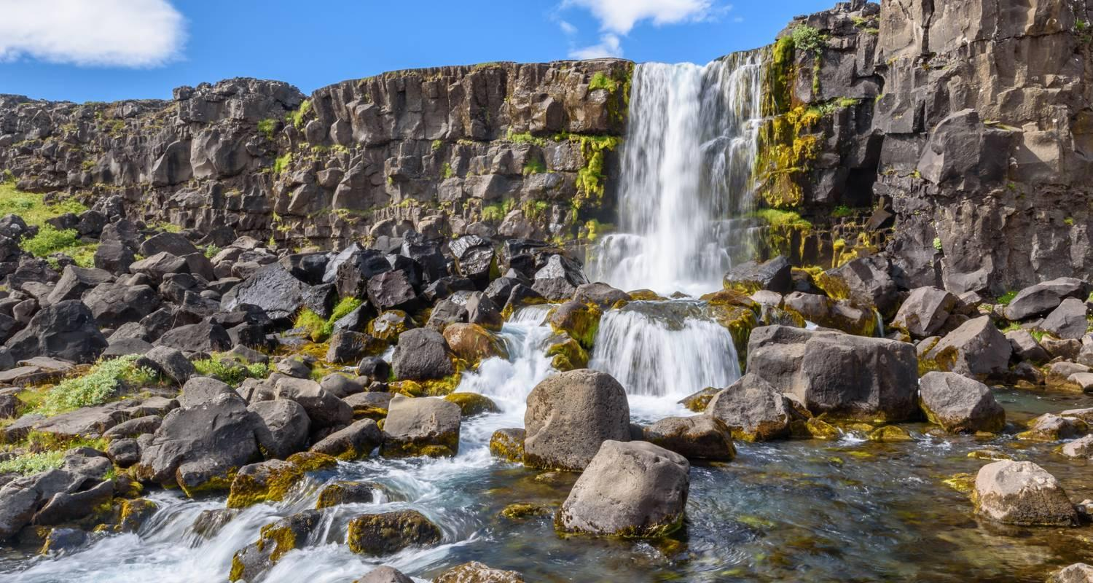









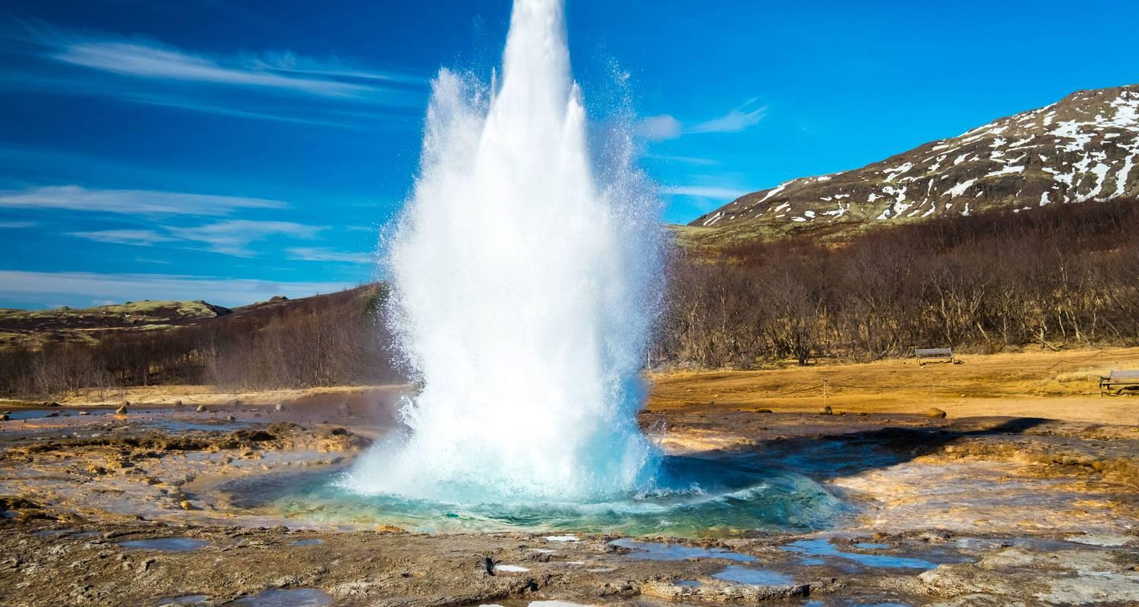

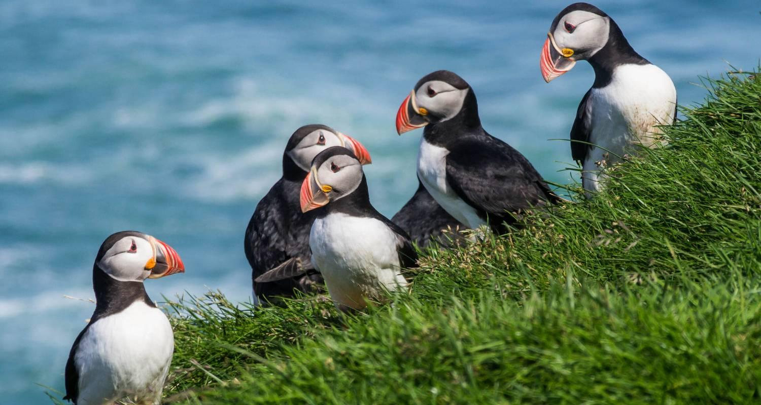

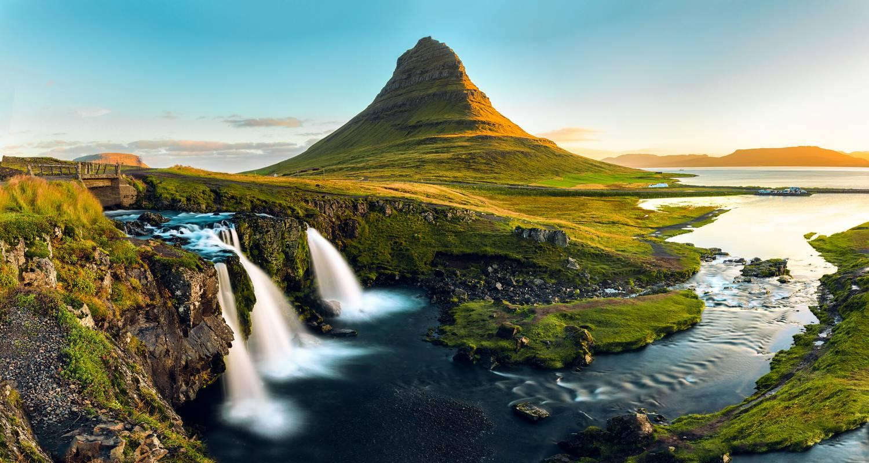

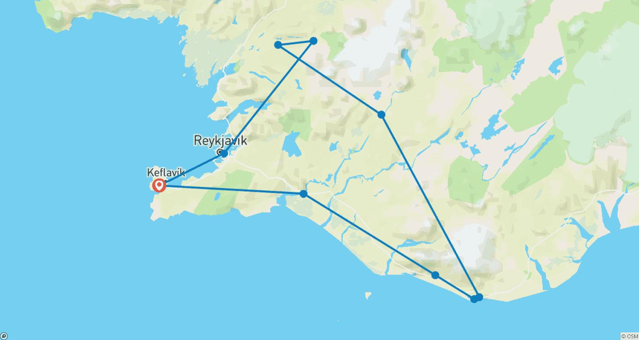

Tour ID: 258465  
Tour Name: Iceland Intensive: Road Trip Along the Ring Road

Tour destinations: ['Reykjavik', 'Keflavik', 'Selfoss', 'Thingvellir National Park', 'Haukadalur', 'Gullfoss', 'Vik', 'Skogafoss', 'Reynisfjara', 'Hofn', 'Skaftafell', 'Svartifoss', 'Akureyri', 'Reykholt', 'Hraunfossar', 'Húsafell', 'Borgarnes', 'Akranes', 'Gunnuhver']

Tour destinations images:









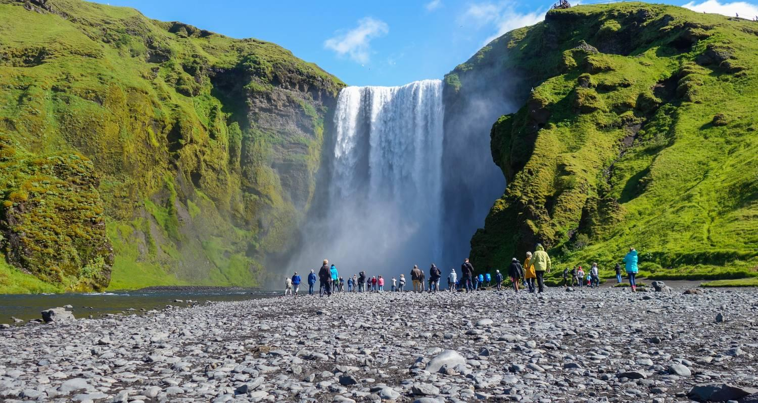

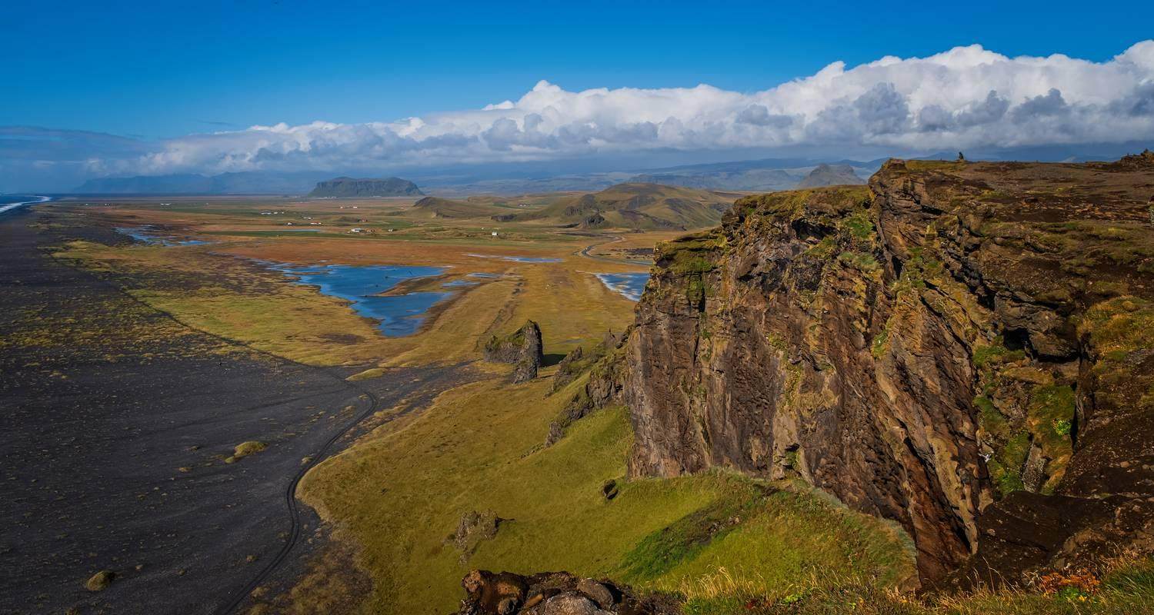





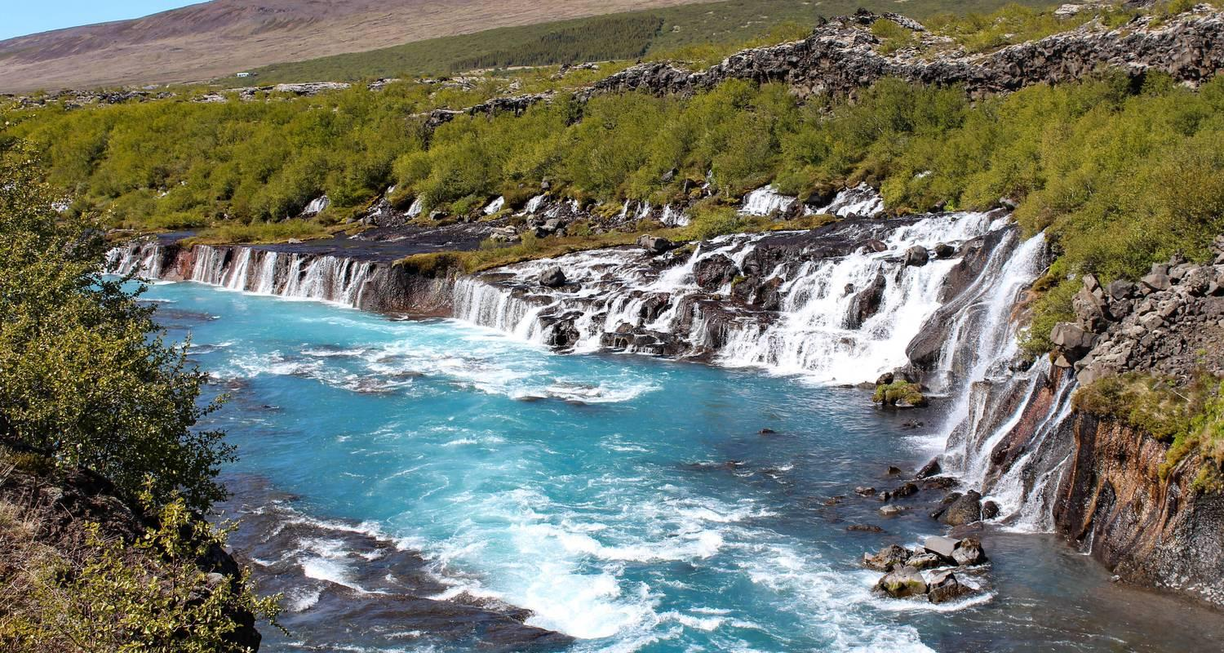

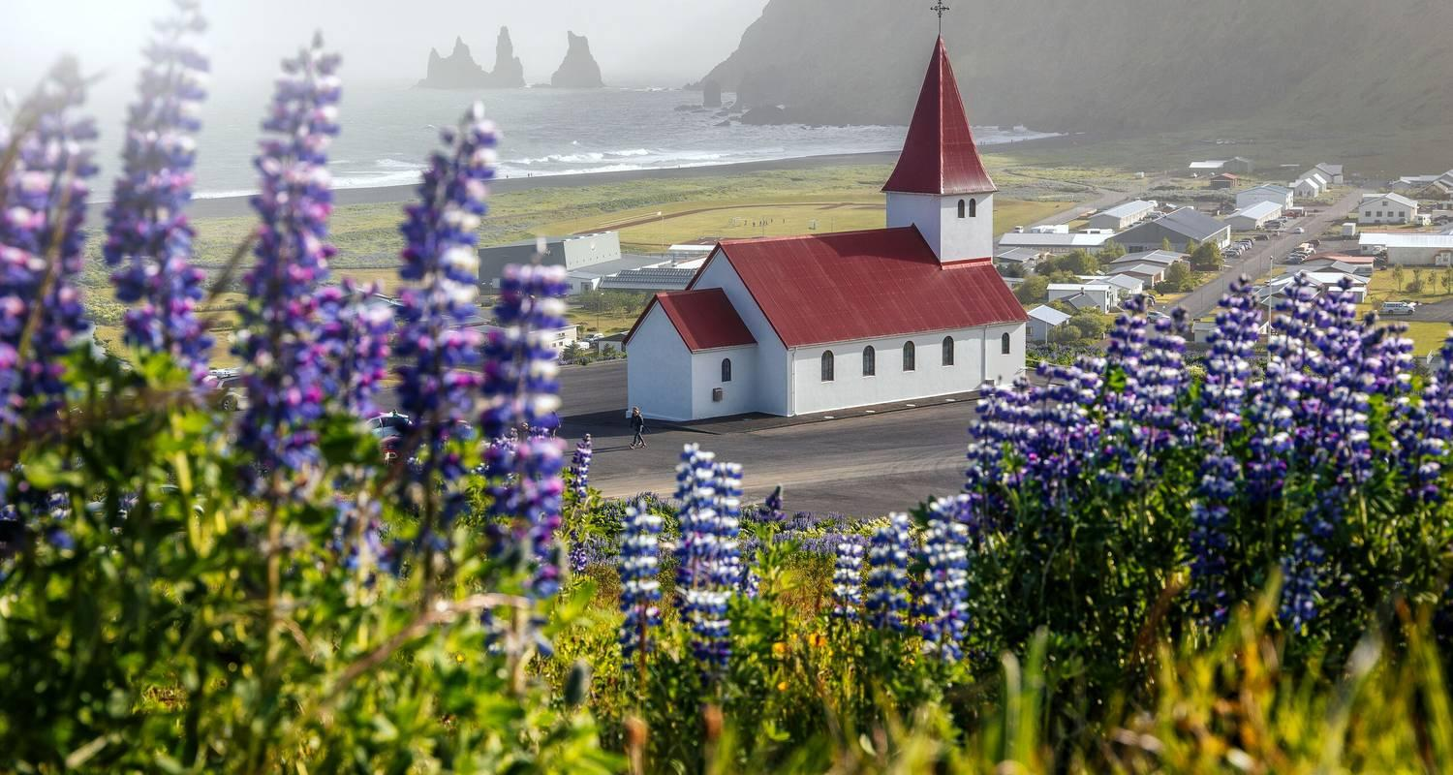

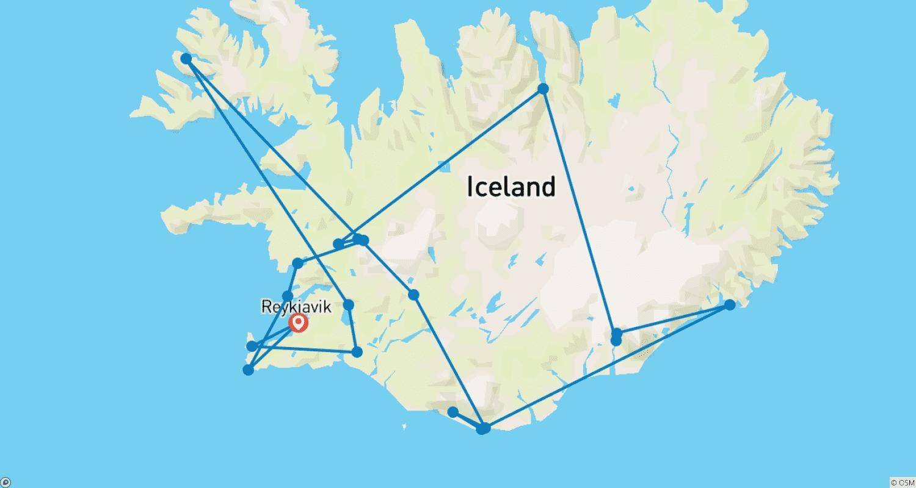

Tour ID: 258516  
Tour Name: Hidden Iceland: Road Trip to the Islands of Vestmannaeyjars

Tour destinations: ['Keflavik', 'Reykholt', 'Selfoss', 'Húsafell', 'Skogafoss', 'Reynisfjara', 'Vik', 'Skaftafell', 'Svartifoss', 'Gullfoss', 'Reykjavik']

Tour destinations images:



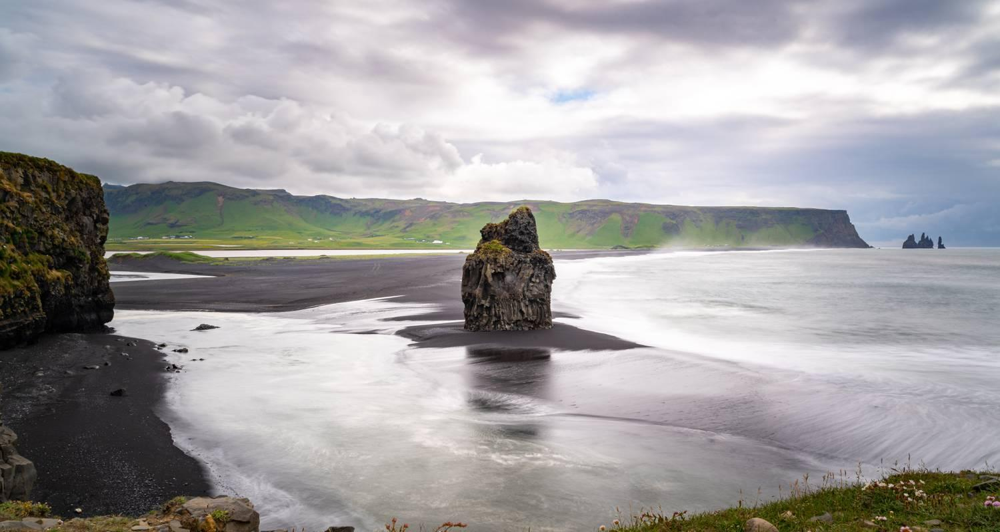













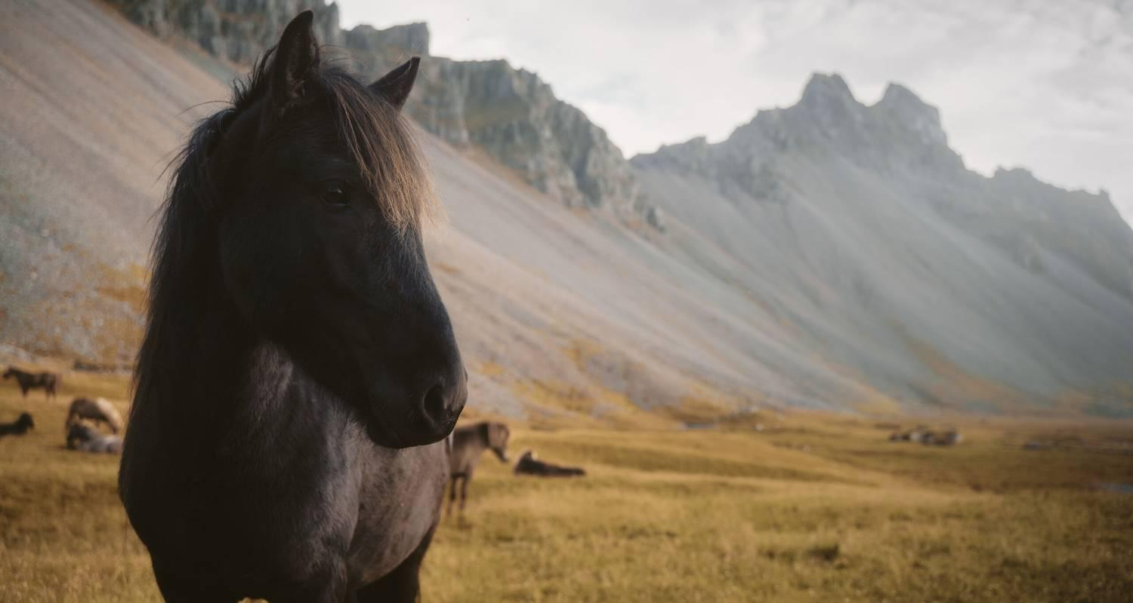



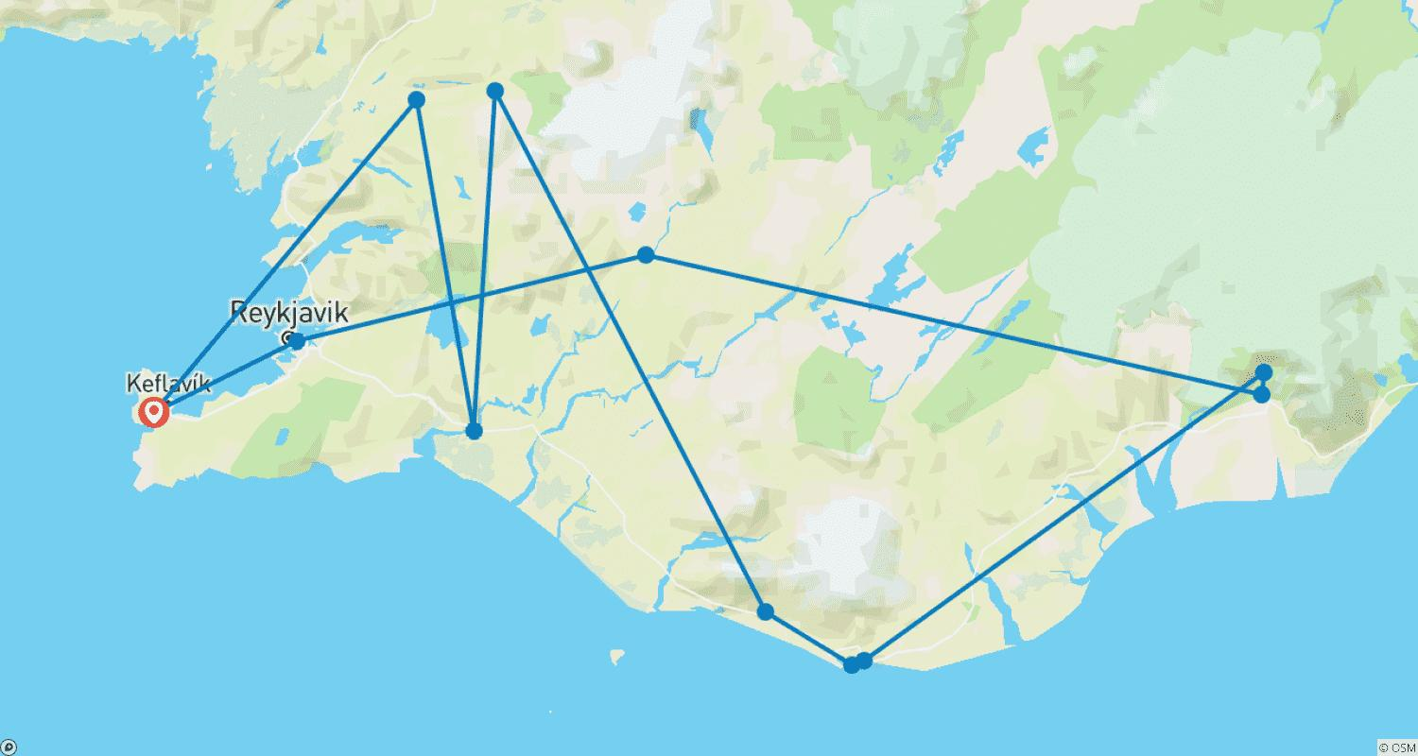

Tour ID: 259056  
Tour Name: Island Hopping in & around the Arctic | Spitsbergen, Iceland & Faroe Islands: Southbound

Tour destinations: ['Oslo', 'Longyearbyen', 'Spitsbergen', 'Jan Mayen Island', 'Akureyri', 'Godafoss', 'Husavik', 'Bakkagerdi', 'Faroe Islands', 'Streymoy Island', 'Lerwick', 'Bergen']

Tour destinations images:

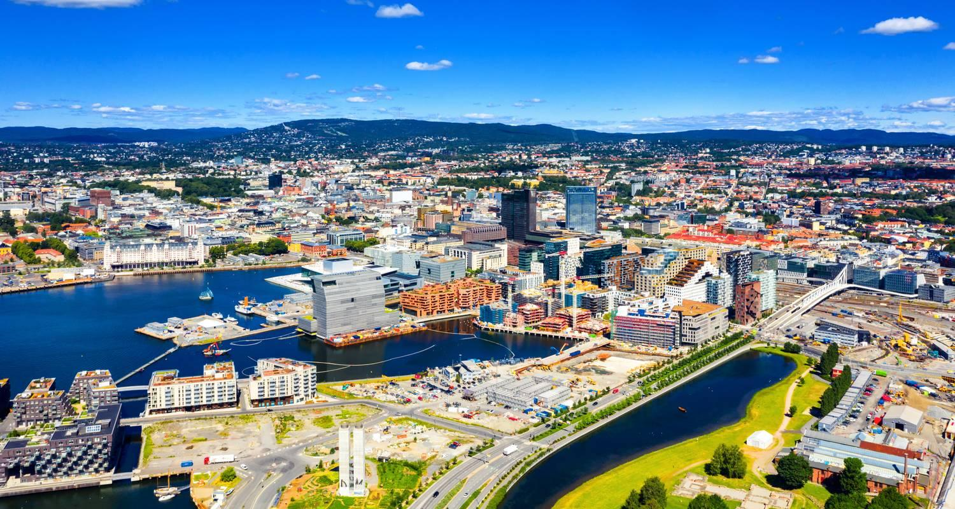

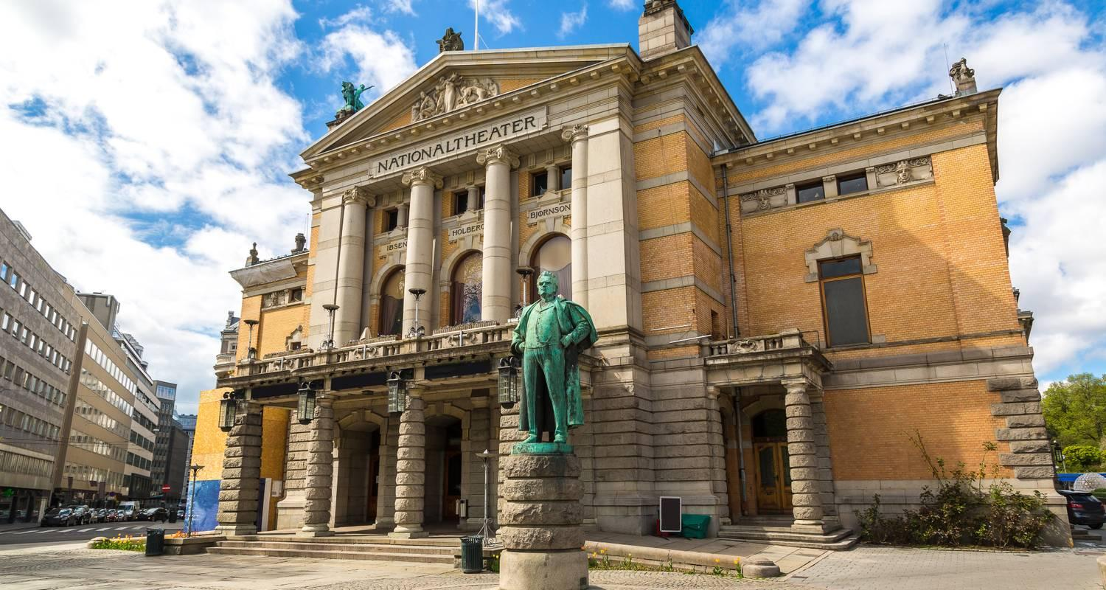

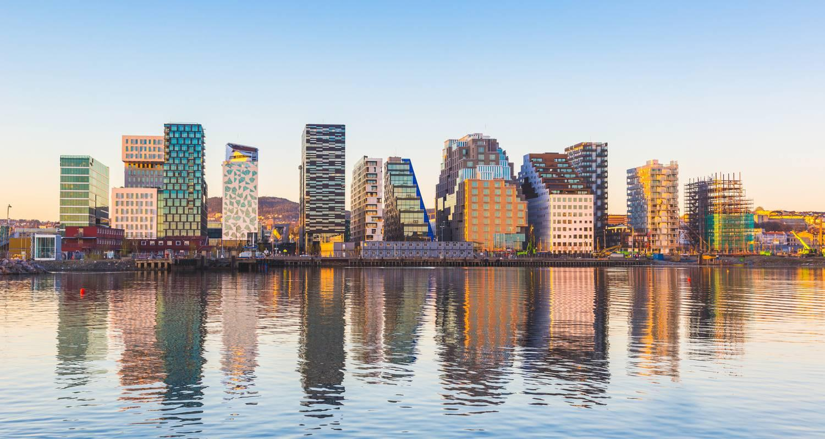

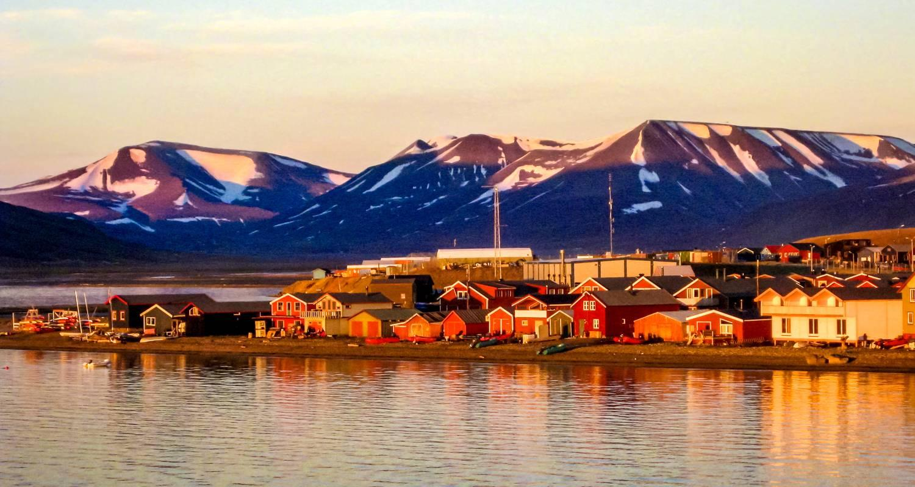

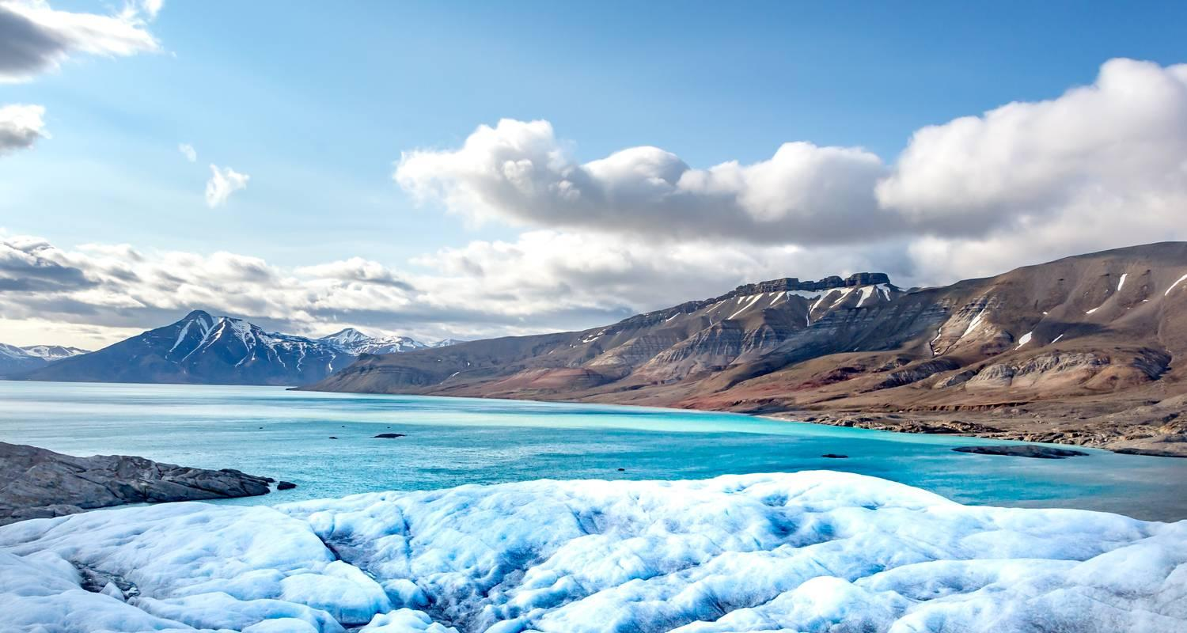



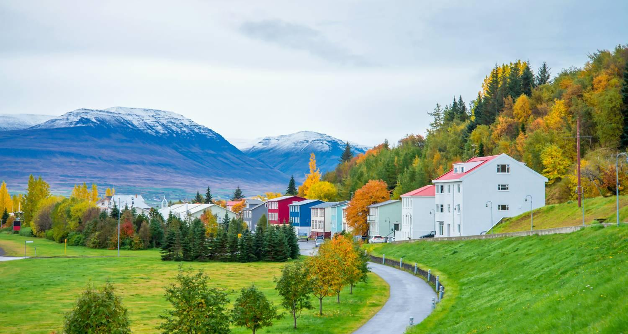

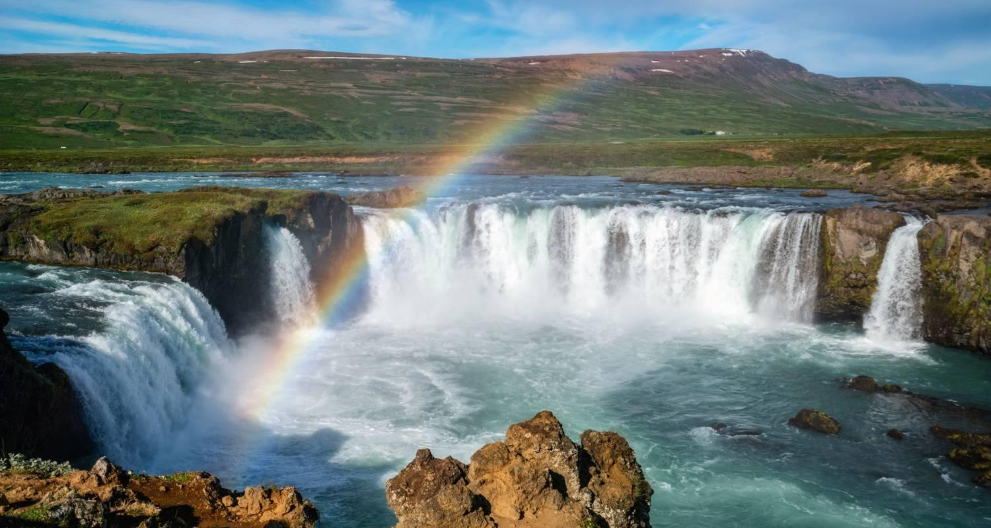

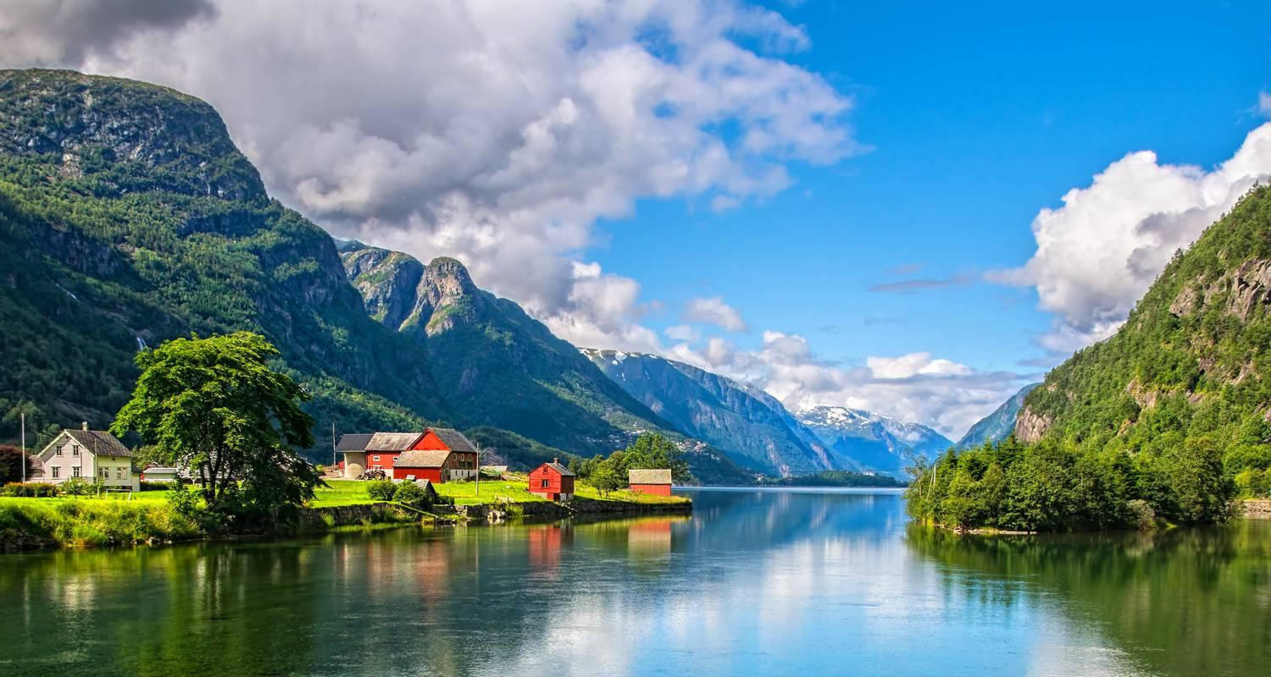

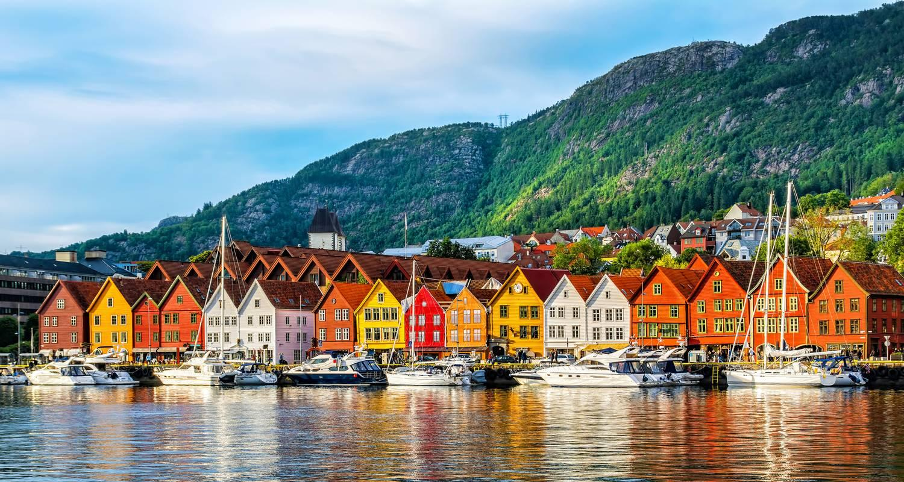

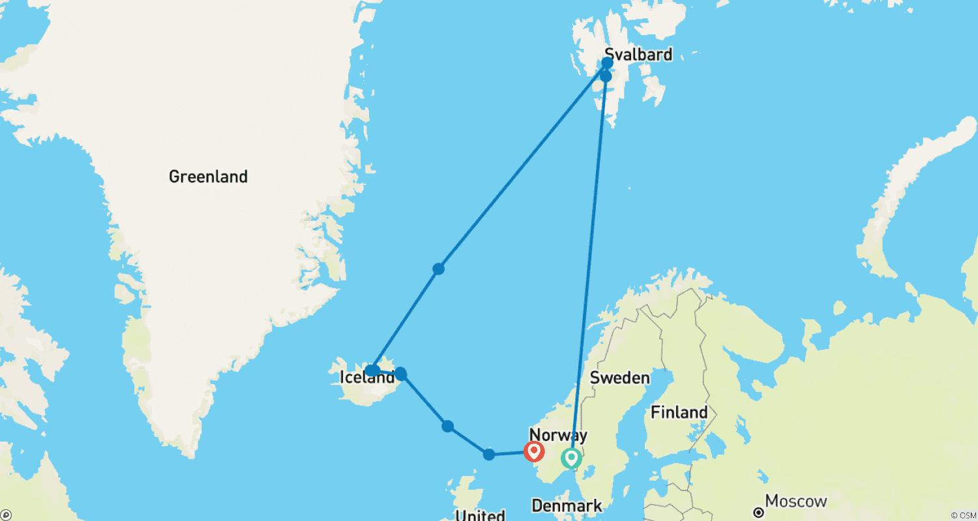

Tour ID: 259063  
Tour Name: Wild Islands of the North Atlantic | Reykjavík to Edinburgh

Tour destinations: ['Reykjavik', 'Heimaey Island', 'Snæfellsnes', 'Patreksfjordur', 'Akureyri', 'Godafoss', 'Grimsey', 'Seydisfjordur', 'Runavík', 'Streymoy Island', 'Lerwick', 'Fair Isle', 'Edinburgh']

Tour destinations images:



